A p-V diagram for a standard Diesel cycle is shown below;

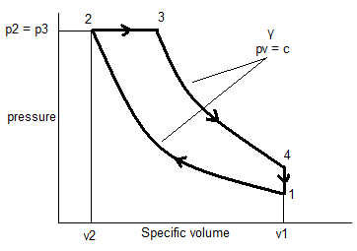
Formula;
$η_{l }$= 1 - $\frac{\left(T_{4}-T_{1}\right)}{γ\left(T_{3}-T_{2}\right)}$

