Fast fashion’s ethical makeover?
10Oct
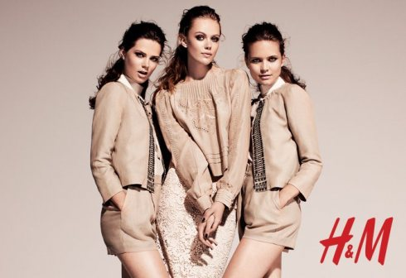H&M Conscious Collection, Fall 2011
Fast fashion is both a profitable and highly controversial business tainted by waste and sweatshops. It’s no secret that large retailers destroy their unsold clothing or that third world workers are constantly being taken advantage of. Recently, fast fashion havens H&M and Zara were faced with unsettling claims of unethical labor practices. Over a thousand workers have reportedly fainted from working in a Cambodian factory that produces stock for both H&M and Puma. It has been discovered that Inditex, the parent company of Zara, has been sourcing a part of its production from a Brazilian sweatshop filled with immigrant workers.
These retail giants are swift in denying responsibility, claiming that the onus should fall on the factory owners that the work is outsourced to. Ultimately, these retailers should be taking greater ownership in sourcing their products and have a better understanding of what goes on in their supply chain. Whether they were honestly unaware or turning a blind eye to keep costs low is debatable.
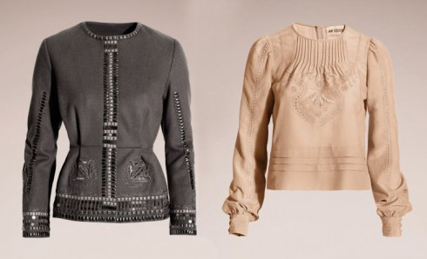Recycled wool blazer $99, Organic cotton blouse $29.95
Ethical shopping is difficult because everything you pick up is likely to have harmed someone somewhere in the course of its construction. Niche retailers that specialize in ethical fashion are great in theory but can be difficult to access and limited in style range, which makes it difficult to appeal to mass markets. Similarly, second hand shops are not for everyone. Given a more accessible outlet and wider range, people may be more willing to purchase and pay a premium for ethical fashion.
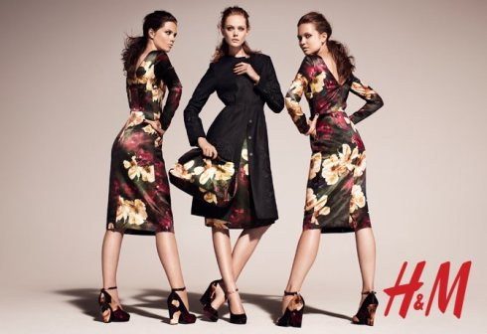
Enter the H&M Conscious Collection, H&M’s attempt at a “more sustainable fashion future”. The initiative first launched last spring and released its latest collection this month. This fall’s looks boast midi hemlines and deep florals constructed from organic hemps, cottons, and recycled wool.
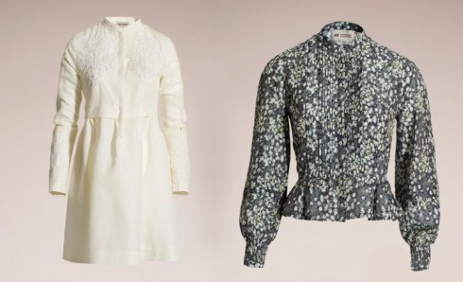Organic cotton dress, Organic cotton blouse $29.95
From a business point of view, it’s surprising that it’s taken this long for a major retailer to realize the gains in moving towards an eco-friendly business. As people become increasingly aware of their consumption patterns on the environment and learn more about the benefits of organic goods, there is a clear gap in the retail industry where mass market and eco-friendly fashion intersect. The high costs associated with producing sustainable fashion can result in greater gains through improved brand image, customer loyalty, and increased foot traffic.
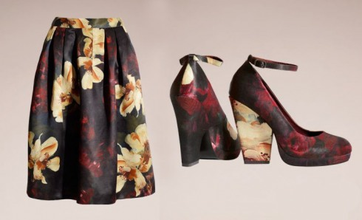Organic hemp skirt $59.95, Shoes $59.95
While this does not excuse many other ethical issues associated with fast fashion, I appreciate the efforts of H&M to bring sustainable fashion to the masses. Hopefully this move will encourage other fast fashion outlets to take a step towards eco-friendly fashion as well.

