7. The figure below has six scatter diagrams for hypothetical data. The correlation coefficients, in scrambled order, are:
-0.85 -0.38 -1.00 0.06 0.97 0.62
Match the scatter diagrams with the correlation coefficients.

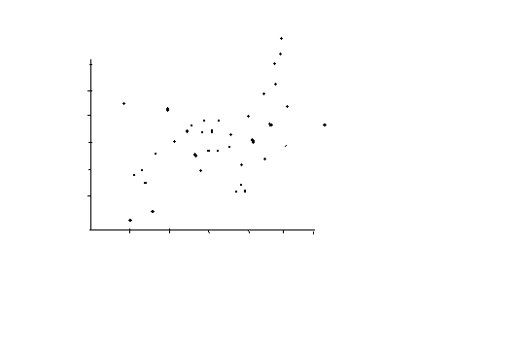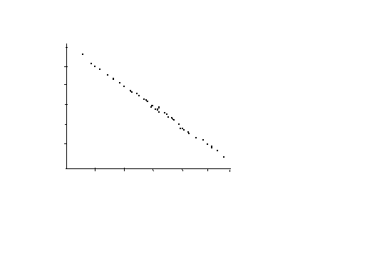
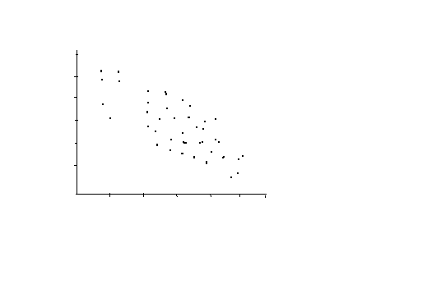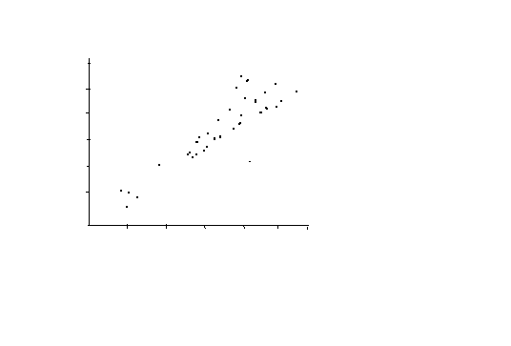
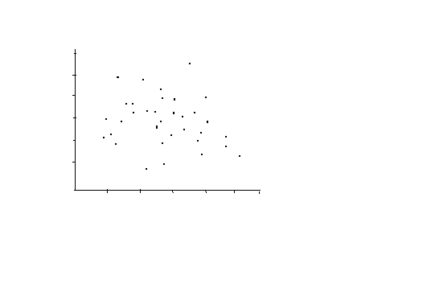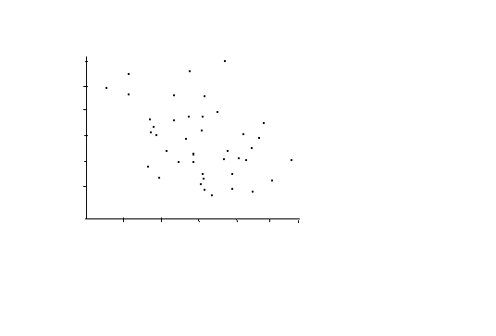

9. Find the correlation coefficient for each of the three data sets shown below.
X y x y x y

1 5 1 1 1 2
1 3 1 2 1 2
1 5 1 1 1 2
1 7 1 3 1 2
2 3 2 1 2 4
2 3 2 4 2 4
2 1 2 1 2 4
3 1 3 2 3 6
3 1 3 2 3 6
4 1 4 3 4 8

1. The r.m.s. error of the regression line for predicting y from x is______.

(i) SD of y
(ii) SD of x
(iii) r x SD of y
(iv) r x SD of x
(v) $\sqrt{1-r^2}$ x SD of y ( I am not sure, am I right?)
(vi)$\sqrt{1-r^2}$ x SD of x

Excel (Correlation)
The attached dataset scores.xls has two variables both numeric:
- Midterm (scores)
- Final (scores)
1. Compute summary statistics of the two variables and plot the data and comment of the relationship between midterm and final scores.

2. Compute the correlation coefficient, r, between midterm and final. Interpret your findings.

