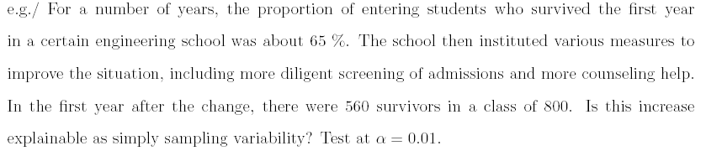

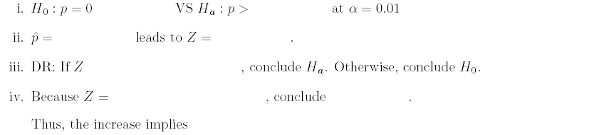

(The Problem is from Hypotheses Test.)

