. To get the best deal on a CD player, Tom called eight appliance stores and asked the cost of a specific model. The prices he was quoted are listed below:
$ 298 $ 125 $ 411 $ 157 $ 231 $ 213 $ 304 $ 272 Find the Standard deviation
2. When investigating times required for drive-through service, the following results (in seconds) were obtained. Find the range, variance, and standard deviation for each of the two samples, then compare the two sets of results.
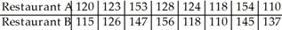
3. A company had 80 employees whose salaries are summarized in the frequency distribution below. Find the standard deviation. Find the standard deviation of the data summarized in the given frequency distribution.
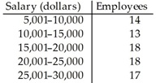

4. The manager of a bank recorded the amount of time each customer spent waiting in line during peak business hours one Monday. The frequency distribution below summarizes the results. Find the standard deviation.
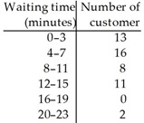
5. The heights of a group of professional basketball players are summarized in the frequency distribution below. Find the standard deviation.
