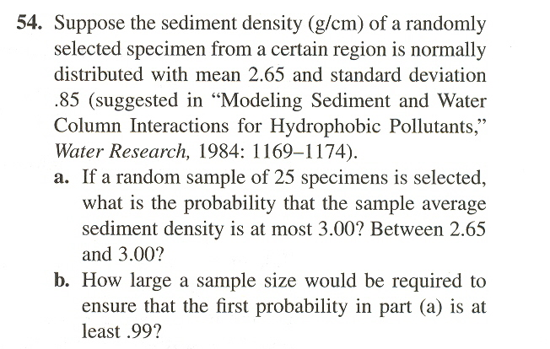

(The problems are from Joint probability distribution and random samples.)

