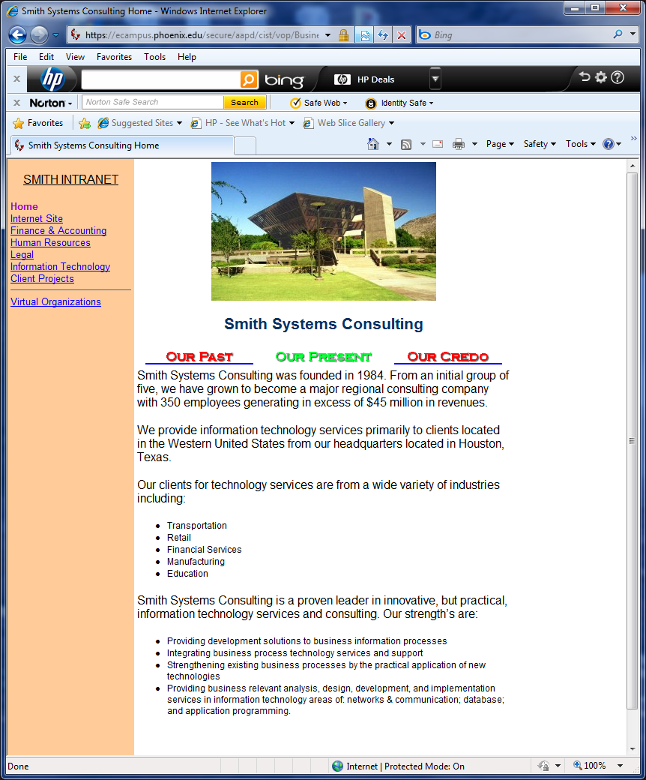

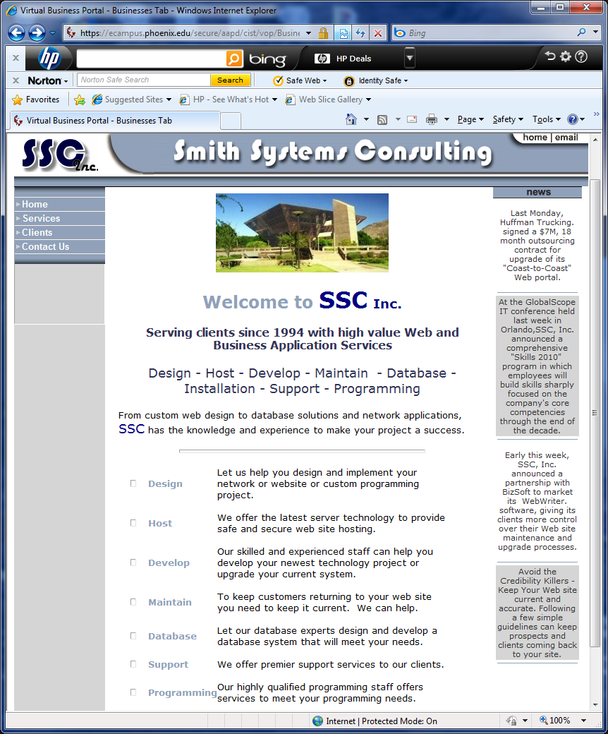

Background: Smith Consulting is a firm that has been contracted to develop the Frequent Shopper Program for Kudler Fine Foods. The student will complete the following individual assignments in Weeks 2-4, in the context of the firm working on the project.

**Research**, write, and provide a 4-6 page proposal of the alternative methods the firm might consider for completing the Frequent Shopper Program. Include the following in the proposal:

•         Explain the advantages and disadvantages for each method relative to this project.

•         Explain how the firm would conduct testing for each development method.

Please provide 2-3 references.