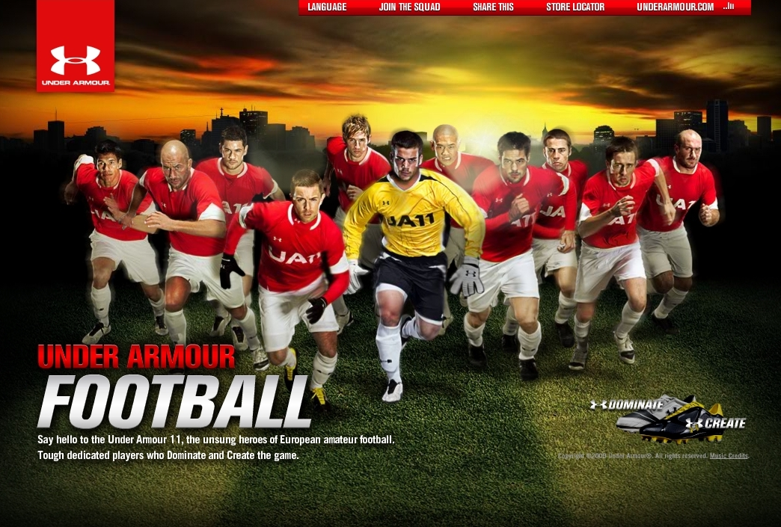
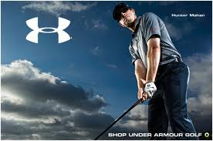
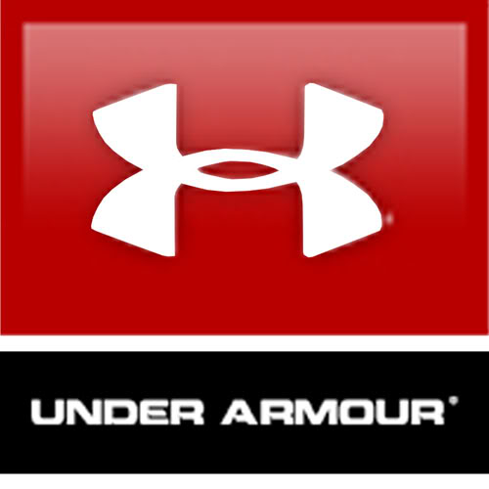
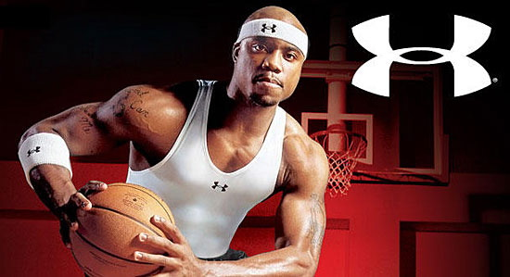
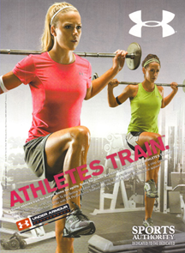
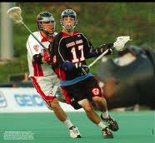
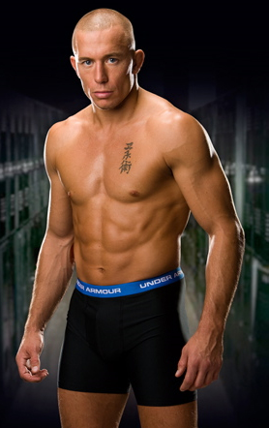
MBAS
Fundamentals of Marketing

“You do something so you can get a quick buck and that may look good on the revenue chart, but only for a little while. What you do must protect your brand or you will ultimately fail. If you slap a logo on it, it might sell right away, but the brands that will endure are the ones that respect the consumer.”
Kevin Plank, Founder Under Armour

TABLE OF CONTENTS

Title Page
Part 1: Market Driven 4

Part 2: Customer Profile and Customer Value 11

Exhibits 19

References 22

PART 1: Market Driven

Under Armour: Company Overview and Introduction
Heavy Perspiration. Increasing body temperature. Soaked t-shirts that take too long to dry. These were some of the challenges that Kevin Plank, a former football player from the University of Maryland, tried to address when he founded Under Armour in 1996. His idea was simple; design athletic apparel that would enhance the performance of athletes by wicking away sweat and other moisture to keep athletes dry, regulating body temperature and ultimately allowing an athlete to perform better. What he didn’t realize was that this product would satisfy high-performance athletes for the next 15 years and beyond. In fact, the immediate positive response he experienced provided him the opportunity to supply apparel to division 1 football teams across the US, eventually expanding into other professional leagues and associations. This decision would contribute to the position of Under Armour as one of the world’s top sports brands in 2010, as ranked by Forbes, with brand value at $530+ million. Today, Under Armour continues to produce athletic wear to men, women and youth with product lines that impact all levels of activity.
Is Under Armour Market Driven?
When evaluating the degree to which Under Armour is market driven and customer centric, three areas of the business were analyzed: internal marketing, structural alignment, and marketing strategy. Each of these areas has been evaluated using the “7 unique secrets of market driven leaders” as explained by Pragmatic Marketing. These evaluations were then aggregated, providing the company an overall rating on how market driven we feel the company is. Below is our assessment.
Internal Marketing
Under Armour’s company mission is to “make all athletes better through passion, science and the relentless pursuit of innovation.” The success of achieving this mission starts from within the company, where it is not only communicated throughout the organization, but where employees actively live it, breathe it, and believe in it, because they too are athletes and/or have passion for athleticism. Ultimately, the mission sets to put the customer first, a goal that is first and foremost supported by the organizational culture at Under Armour and communicated by the organizations very own ‘company hero’, CEO and founder, Kevin Plank. As a former semi-professional athlete himself, he understands the vision behind the brand in pursuit of making athletes better. Other examples of internal marketing that supports a market centric organization are explained further below.
For any group sport, success is never dependent on one individual; it involves the hard work, dedication and passion of an entire team. The value of team work is one in which Under Armour sets its cultural foundation on. They believe that an environment of growth and protecting a brand starts with a passionate team that also brings out the passion in others. In alignment with this team culture, are employees that must walk the talk. As an Under Armour brand ambassador, they too need to be athletes themselves or “love performance” to the degree that an athlete would. Another example of Under Armour’s market driven culture is its regular communication with employees at all levels. This includes regular town hall meetings, team websites and project-oriented websites where employees can turn to for information regarding company updates, new product strategies, as well as provide their own feedback, something that is not only encouraged, but expected. This culture of open communication fosters a community of trust. With trust comes better ideas, more creativity, new insights and innovation. This, in addition to everything else mentioned above helps put the idea of athleticism and customers first, allowing for the end consumer to be in the forefront of every business decision within the organization.
Structural Alignment
Under Armour’s market driven culture is supported very well by the internal structure of the organization. From recruitment practices to physical spaces in the buildings themselves, the company always operates to ensure that the customer comes first.
Since employees are also their customers, the belief is that recruitment should also be customer focused. While it’s not a requirement to be an athlete or a top performer, the company actively looks for individuals who have “love for the game (any game!)” in addition to other key attributes the company looks for, such as, creativity and leadership. Furthermore, to ensure that they are well positioned for future growth, Under Armour also has an internship program for college-level applicants, appropriately called the “Rookie Program”. The purpose of this program is much like a rookie program for a professional sports team. The idea is to identify high performing talent and train these individuals in hopes that they can be part of the big leagues in a full time position in the future once they are ready. The Rookie Program is unique in that each rookie has its own assigned mentor, and can also learn about the culture of the organization first hand through team building events and other activities with the staff. New employees (regardless of level) are also required to go through UA101 - an intensive two-day training workshop (similar to a training camp) that teaches employees about the business and the entire value chain model from idea and concept generation to understanding the customer experience at the retail level. It is with this that Under Armour hopes to infuse its employees with a customer-focused approach right from the start of employment. In a published recruitment document, the company even goes as far as requesting pre-employment drug screenings to ensure that all employees do not use or promote any performance enhancing drugs, which is very clearly against their brand. It is clear through these examples that the culture of “team spirit” is supported by their internal structure.
In terms of reporting structure, although each functional area is separated into its own division, Under Armour still promotes team work and idea generation in pursuit of customer focused products through cross collaboration, rotational work and cross-functional assignments. This suggests that communication happens at all levels of the organization and that structures and communication are not siloed. This supports idea and information transfer, which is critical in any market driven organization, especially when the information and insight is about the company’s consumer.
Under Armour has also undergone physical improvements to the headquarters in Baltimore in an effort to become more market driven as well. First, as reported in the Baltimore Sun on September 15, 2011, the company plans to double its headquarters. This expansion entails three important additions. First, to position themselves for long term growth, the company has added more employees to its roster resulting in a need for additional office space. Second, a retail store will also be added. This was in direct response to the number of customers who visit Under Armour headquarters every year, looking for the retail space on their visits. Lastly, Under Armour will also be building its own museum. The museum not only serves as a symbol for the success and growth of the company, but also acts as a meeting place and celebration venue where customers and employees alike can continue to celebrate the success and evolution of the brand together.
Earlier this year, Under Armour also unveiled its “Innovation Lab” – an on-site R&D testing center, at their headquarters. This would allow the company to design, test, and modify new apparel and footwear with state of the art technology, without having to send the products off-site. This is of tremendous value since it allows Under Armour to be more responsive to the needs of their customers, allowing them to be quicker to market ahead of their competitors, with their new innovative products.
Other initiatives within headquarters that support a market driven culture include a strong customer service team that not only welcomes consumer questions but encourages it; a subsidized café that provides healthy meals and snacks to employees, a full fitness facility for employee use, substantial discounts on Under Armour merchandise, as well as discounts on sporting ticket events in the local area. All of these initiatives support athleticism and performance, from healthy eating, to encouragement of physical activity.
Marketing Strategy
Under Armour consistently looks for ways to gather marketing intelligence about their customers. This is achieved by creating a dialogue with their consumers through various touch points outside of a regular transaction. One of the most innovative and unique ways the company is currently doing this is through their Combine Training Camps. These are training camps for various sports and activities that take place all around the US and are targeted to amateur athletes to help optimize their training and skills, as well as potential to help them improve their performance. This strategy has mutual benefits to both the customer and for the company. The amateur athlete (the combine) attends these camps to find out about his or her athletic potential, validate skills, be coached and trained by professionals, and may also have face time with potential scouts for their respective sports. In return, this helps Under Armour learn more about their target customers’ relevant performance measures for each sport category to ultimately help them generate new ideas and plan their next innovative product (see Exhibit 1), as well as provides them a venue to test and promote certain products.
Under Armour also makes use of various online tools to capture information about the customers buying habits and purchasing patterns through web analytics and customer surveys. This helps them anticipate customer demand and preferences. In addition, their social media strategy also aims to create dialogue with the consumer. One tactic used is a fitness and advice blog run by Under Armour that is aimed at learning about what consumers want and are looking for in their next innovative product.
By focusing on the direct to consumer channel, Under Armour has started to open its own branded retail locations. The store itself is themed around the idea of performance enhancement and athletic innovation, and provides a physical location where staff can connect and communicate directly with its consumer, something that was not possible in their previous value chain strategy of selling through a wholesaler.

Our Evaluation of Under Armour
Based on our analysis of Under Armour`s internal marketing practices, their structural alignment and their marketing intelligence, it is evident that they are a very market-driven firm (See Exhibit 2 for full assessment). Some of the areas where they exhibit strengths are their ability to work as a trusted advisor by continuing to study their customers and non-customers to identify potential solutions and opportunities for the firm through various strategic initiatives; Distributed leadership where strategies are driven by market requirements and customer needs as opposed to needs driven by the organization in a bureaucratic manner; Ability to be a strategic partner and solutions provider with their innovative technologies as opposed to being just a vendor; and their ability to market with the big M, which can be illustrated through innovative marketing strategies used to gather customer intelligence such as the use of combines. With that said, there are a few key areas, which we`ve identified that we feel they can improve on to become even more market driven. When building from the outside in, there is an opportunity to have more direct to consumer communication. Although they`ve already started to do this by opening up a few retail warehouses, it could be in their benefit to open more retail stores in prominent locations. This will help further promote the brand and generate awareness for new potential customers. The language currently used to communicate to their customers may be seen as too technical for certain targets. The best way to communicate this is to have tailored communications to each consumer group. This is currently done to some degree, but not at the level that it requires for all groups to understand. Lastly, measuring what matters is important. Their metrics need to be more transparent and how they go about measuring also needs to have more clarity.
Improvements and Recommendations
One of the biggest challenges Under Armour will face as they continue to grow, is how to stay market driven and not lose sight of being customer focused. This is especially important if they want to remain relevant to the consumer and continue to be seen as a solutions provider. With that in mind, recommendations for the short term, medium term and long term are presented below. In the short term, it is essential that Under Armour continues their strategic marketing intelligence efforts. The strength of their brand comes from being able to provide solutions to the customer for their performance needs – and how they arrive at these needs is key. As communications channels and preferences of how individuals would like to be communicated to keep changing, the company needs to continually identify ways to create dialogue with their customer. This will help anticipate any future risks, barriers, or changes in preferences to help them stay ahead of the game.
In the medium term, the company needs to consider long term company growth and future opportunities and whether or not existing practices and solutions will be viable in taking the business to the next level. They need to identify and launch the next new product or technological innovation to keep them differentiated from other competitors in such a saturated market. From a strategic partnership perspective, Under Armour could consider partnering with gyms or athletic facilities where their interactions with target customers will be very valuable since communications efforts will be more efficient.
The majority of sales and market share for its current product come from the US. Therefore, in the long term Under Armour might want to focus more attention on expansion initiatives into other regions of the world. This overcomes the risk of dependency on a single/similar market for revenue source. They may also want to consider new product opportunities that are in alignment with their current brand strategy such as providing health foods and products. That way they can be seen as an all-around performance improvement brand from apparel to healthy eating.

PART 2: Customer Profile & Customer Value

Our Target Customer
When identifying which customer tribe our group felt represented the best opportunity for Under Armour we first considered a range of tribes. We considered High Performance Athletes, or individuals who spend 5% of the time performing an athletic activity and 95% of their time training for it. These individuals are also known as your professionals; Aspiring Professionals, which can be considered high school teens or young adults training to one day reach the professional status and participate at the high performance level; Moderate Performance Individuals, who are individuals that engage in moderate performance activities in order to maintain a healthy body image as well as a healthy lifestyle, but are bounded by time and other outside pressures; and Image Seekers, individuals who are not performance driven and purchase products strictly for the image that it may portray to others (see Exhibit 3).
The tribe that we have selected are the Moderate Performance Individuals. We have identified this group of individuals, as professional males, age 35 or older, working 55+ hours a week, and have a mid- to high-income level. His passions include new experiences, adventure, and achievement and he considers himself as a recreational athlete who still participates with a high level of intensity. He values a balanced lifestyle that may consist of his career, family, social life, leisure and personal fitness, but his biggest challenge and barrier to achieving this goal, is time.
What Job they are seeking to accomplish by hiring the product
This group will hire Under Armour to accomplish a number of different intangible and tangible jobs. In terms of intangible jobs, the moderate performance individual strives to purchase a product that will help them to not only look good and feel good, but to help them be in shape and stay in shape.
Because they are limited with the amount of time they can spend on physical activity, efficiency is essential for this group. The limited amount of time they have to spend on physical activity must be done in a way that maximizes their efforts. Thus, they are looking to hire Under Armour for tangible product attributes that will help them perform better with the use of the newest innovative technologies, which may help bring their performance to the next level.
Why we chose this Tribe
The issue of body image is a topic area that is typically associated with women. However, more than ever, males are increasingly becoming dissatisfied with their personal body image as well. This can be attributed to a number of different factors including the cultural tendency to judge people on their appearances as well as the ideal male body type that is currently portrayed in the mass media; a male who is strong, lean and muscular. This has had significant effects for males as it has led to a distortion of what a healthy body image is. More and more, males increasingly have concerns regarding their stomachs, chests and hair loss. In fact betterhealth.com estimates that 23% of men in the healthy weight range believe they are overweight. The impact of this is significant as there has been an increasing trend for cosmetic procedures done for men. According to the American Society for Aesthetic and Plastic Surgery, nearly 1 million American men underwent a cosmetic procedure in 2010. This becomes an extremely important segment in today’s society as this tribe seeks both change and products that will help them achieve the ideal body image. It represents an important opportunity for Under Armour as these individuals may not aspire to become high performance athletes but would ideally still like to look like one.
Profile Characteristics and Cultural Values
In order to understand the types of strategies that would best target this customer, it is very important to first get a better understanding of the characteristics and a deeper profile of who this customer is. Based on this thought, below is a compilation of some important information that must be considered when developing the marketing strategy for this customer.

Benefits Sought: When the customer purchases this product, he expects both tangible and intangible benefits. Some tangible benefits that are important to the consumer is the quality of the product. This customer seeks to have durable, long lasting apparel that can withstand intensive work outs. The product must also be innovative in terms of its functionality and must be proven to increase performance levels of those who purchase it. It must also provide the benefits of the ideal body image because this group expects that the product will assist in the efforts of becoming in ideal shape. Some intangible benefits that are important to the consumer include the benefits of feeling powerful and superior as the individual arrives closer to becoming an image of a top athlete or top performer. This also ties closely to reputation since the prestige of the product will help with body image also.
Consumer Life Cycle: The moderate performer is constrained by time pressures. A balanced lifestyle is important, however, given all the pressures he faces on a daily basis coming from work, family leisure and social life, balance is sometimes difficult. He is vulnerable about his economic position, and is even more vulnerable when it comes to his social position as the risk and challenge comes from a need to seek the ideal body image. Corporate social responsibility is important but may not necessarily be a driving factor in the decision to purchase.
Usage Situation Profile: This is an educated consumer who is aware of the brand and the product but may lack the complete knowledge of all the technical functions and innovations about the product itself. Therefore, he is aware of the products tangible attributes and still would like to learn more about the benefits and how this technology can help him. This is especially important since many competitive firms also have similar technologies. He is looking for product differentiation and how this particular product will serve him best. As a heavy user, he is also focused on intangible attributes such as social uses of the product and the corresponding perception of using the particular brand.
Consumer Belief Profile: This customer likes the product offering, but can gain more out of the intangible benefits if he was provided more information about the tangible attributes. He is aware of the amount of research and development that goes into making this technology and believes the brand is superior quality. He also believes that the social benefits of wearing the Under Armour brand will help portray his image of being fit. He believes that from a tangible aspect, the product is reliable and worth the price. He would rather not pay for a product at a cheaper price if it means sacrificing quality and hindering performance.
Price Sensitivity: This target has medium to low price elasticity and is not considered to be price conscious. He is not only loyal to the product but to the brand and willing to pay a premium for what he perceives to also be premium. When buying the brand, you are also paying for prestige and performance associated with it. Therefore, lowering the price might have adverse effects on the item itself since it may lower the perception of the value and prestige of the product. The company has a competitive advantage here since prices may be manipulated and it likely won’t affect consumer demand.
Media Usage: This group is less engaged in media requiring high cognitive effort and would prefer experiential media instead. He looks for the next new “gadget” in store, specifically if it saves him time. He appreciates different communication channels and different experiences, especially if it’s more convenient for him to use. This includes use of television, video, lap tops, iPads, smart phone etc.
Consumer Choice: This customer is both rational and experiential. They would like to know that what they are purchasing will help them achieve their goals through product functionality but also purchases the product for the experiential and intangible benefits.
Loyalty Level Profile: This group has potential to be a highly loyal customer as long as their intangible needs are met. The social and psychological risk of not obtaining their goal of an ideal body image is seen as significant and a product that can help reduce these risks is extremely valuable to him.
Cultural Values: The cultural dimension that speaks to this particular customer group the most is the idea of masculinity. Masculinity in our society is reinforced through communication channels such as mass media. It is highly aligned with social norms, where males are seen as the tough, strong, built, ego-oriented individual, who believes that money and work are both equally important. Some of the ritual behaviours this group participates in include: personal grooming, health and fitness and working out at the gym, family activities, work or office events, and some more cultural events such as a “guys night out”.
Elements of Customer Value
Short Term Customer Satisfaction: The moderate performance customer is aware of all the different brands and technologies in the current market. He is able to identify other competing brands, but most importantly is aware that Under Armour uses innovative technology in its product line. However, he needs more specific information and guidance on exactly which product is good for him and how it can help when it comes to driving performance. A short term customer satisfaction solution would then be a vehicle where this consumer can be further educated about the technologies of each type of product line Under Armour offers, to help him choose which product is most suitable for his performance/workout needs. Perhaps a consideration could be an online tool where he is able to input variables associated with the type of works outs and physical intensity he’s looking for, which then automatically generates a type of product that is best for him and which also explains all the specification of that particular product and tips on how to use it and make the most out of it.
Relevance of tangible attributes of brand/service to consumer: The tangible and functional attributes of the product are very important to this group. He seeks durability, good quality, and a product that fits well and helps him to look good from the moment he puts on the product. What the customer would value then may be demonstrations on how the products can be used in different athletic settings. Ideally this product would be used in places other than a gym or fitness facility. The moderate performance customer would also like to know that it can reap the benefits of the technology when engaging in other physical activity such as recreational or team sports. An in-store demonstration or fitness expert within retail locations might be helpful to this group (such as personal training sessions, and support groups).
Relevance of intangible aspects of brand/service consumer: The intangible aspects of this brand are also extremely important to this group. The idea of physically obtaining the ideal body image for this individual is also a mental,intangible desire. He seeks social acceptance, and looks for a brand that instils confidence. The brand must be seen as having a level of prestige to it, this insinuating that it must also be high in quality and value. What this customer values then, is a brand that consistently communicates to the target as well as the wider public the prestige that this brand portrays – ultimately the brand will say a lot about the individual who is wearing it.
Customers feeling of being treated with respect: The moderate performer we have identified is a fairly accomplished individual. They have made great progress in their career and family life while still being able to socialize, have fun and make time for themself. Respect comes in the form of a genuine brand, that has authenticity behind the technologies it offers. In addition, it may also come from the level of service or perceived service they are getting whether in store, online, or other forms of support functions.
Customers feeling of supporting a socially responsible and Ethical company: Supporting a company that is socially responsible has a lot of merit. However, it may not be at the forefront of this customers purchase or decision consideration unless it has become a wider issue (ex. Nike and child labor). On that note, all things the same, a socially responsible and ethical company still sets similar competitors apart and therefore a company that does not engage in socially responsible activities is at risk at losing a lot of potential customers to other competitors.
Tangible Costs: We have identified that this target is not particular price conscious or price sensitive. They have identified that because their body image is important to them, they are also willing to pay for the best products that will help them achieve this goal. On that note, other than price, another tangible cost that they face is the cost of time as a result of their lifestyle. The implication of this is the need for a product that is durable, and high in quality in order to limit transaction costs. The idea is to spend cash in the short term to save them transaction costs of having to repeat purchases. Perhaps an idea to consider are ecommerce initiatives to help guide the sale.
Intangible Costs: Reputation and image is of key importance and the more the brand is viewed as unique and high end, the more it increases this groups’ need for this product. They are looking for a product that can also boost morale and in terms of function, the brand must be truthful in what it sets out to do otherwise it will result in loss of respect and will provide the customer a leeway to purchase another competitors products.
Summary of Discussion of Customer Value
We have identified the tribe as the individual that engages in moderate performance, have described their profile and personal characteristics and have also identified the elements of customer value important to this tribe. When developing a marketing strategy for this particular tribe, it is also important to understand which of these elements of customer value is considered to be a priority. When it comes to elements that are top priority, Customer Satisfaction, Tangible Benefits of the Brand and Intangible Benefits of the brand are important. This is primarily because it directly addresses the jobs that the individual is hiring Under Armour for. In terms of customer satisfaction, the tribe already has an understanding of what the product is and has an idea of the tangible benefits that the product provides. However, they need to be educated and informed on which product is best for their particular needs in order to turn interest in to an actual purchase. Tangible benefits of the brand are also of high importance and priority as the customer needs to know that what they are investing in will help maximize their efficiency and efforts so they can achieve their goals. This priority cannot be compromised and is seen as essential part of the brand and product they are purchasing. Intangible benefits of the brand are also seen as a top priority when communicating with the customer. They understand that although the ideal body image will take time to achieve, they would like to at least immediately look good, feel good and empowered in the products that they purchase for this cause. Elements of customer value that may be considered a medium priority are: intangible costs, tangible costs and to be treated with respect. In terms of tangible costs, this is a group that is less sensitive to price and more sensitive to time. Overall, they will still pay and make time for a product if it allows them to achieve their objectives. As a priority it is important but not as important as the actual function and tangible benefits of the product itself. This is similar for intangible costs and being treated with respect. They are aware of the social pressures that are placed on them and their society to maintain an ideal body image, and therefore the intangible costs and being treated with respect based on the types of products they wear are important but not as significant as some of the top priorities we mentioned above.
Finally, the value element that is low priority is the idea of supporting a company that is socially responsible and ethical. This is not to say that it is not important, but first and foremost, the top priority is placed on the individuals themselves and the products that will help them achieve their goal of an ideal body image.

EXHIBIT 1: Under Armour Combines
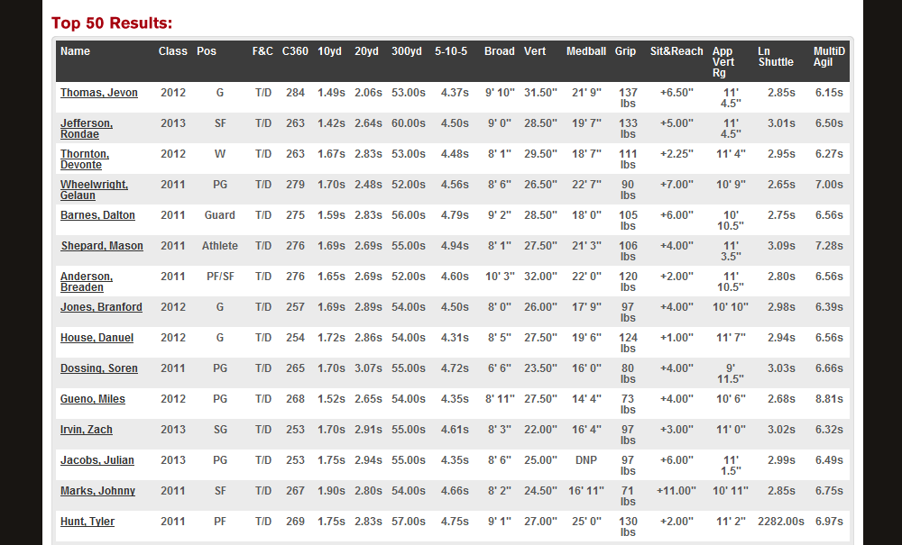

EXHIBIT 2: Under Armour’s Market-Driven Assessment

Market Driven Secrets | Score | Assessment
- Work as a trusted advisor | A | Under Armour continues to study their customers and non-customers in order to provide the best value to their current customers, and seek ways to find solutions and opportunities in markets they are not currently active in. This is evident in their recent expansion into footwear, their increased efforts to go direct-to-consumer, as well as their continued emphasis on marketing intelligence through initiatives such as Under Armour Combines, just to name a few.
- Build from the Outside In | B+ | The company makes effort to understand what customers are looking for and then build solutions based on the customer’s needs. This is done in several ways, through strategic recruiting and hiring employees that have similar needs and passions as their target customer, through dialogue in social media, and through recent initiatives to have a more direct to consumer approach.
- Simple is Smart | B | Their products address a specific problem, that is the need to improve athletic performance through innovative technologies and they do it effectively. The communication is simple and clear for those who engage in high performance athletic activities, although it can be argued that other target segments, especially new markets or tribes may not be so familiar with the language and marketing jargon.
- Leadership is Distributed | A | Strategy is focused on bottom up strategic planning. Autonomy and creativity are characteristics and values they instil in their employees throughout the organization and as such, they are encouraged to think strategically at their specific business unit levels. Because employees are also customers, they also have a clear indication of market requirements, so employee feedback is highly valued. However the company also takes the feedback of customers very seriously, much of which drives their internal marketing and structural alignment.
- Stop being a Vendor | A+ | The Company is established based on the philosophy of solving problems and it continues to do so by talking to customers and incorporating their feedback into their products. Again, their combines as well as their blogs about health advice enable two way communication that provide invaluable insights into the types of problems customers face, which ultimately help the company develop innovative solutions for.
- Marketing with a Big M | A+ | Under Armours marketing strategy is used both as promotion and advertising as well as identifying the customer’s problems. With this approach, they have developed a very good understanding of the market place. They are not just inventing things without input or extensive research they are making sure that everything they do is closely corresponded to market intelligence. Ultimately, their marketing is used effectively.
- Measure only what matters | B- | There are a number of ways to measure what matter and insights into the company tell us that although they do this well today, there is still room for improvement. Customer satisfaction is an important metric, but prominently measured by a professional athletes loyalty (the individuals who wear the brand that aren`t paid to wear them). This however, does not say anything about the individuals in other target markets who may or may not be satisfied with the brand. Consumers take part in a lot of the communication up front when it comes to idea and concept building. Under Armour might also find it extremely helpful if the same individuals also took place in customer satisfaction measures.
Total Score | A

EXHIBIT 3: Customer Tribes - Scale on Level of Athletic Performance

Moderate Performance
Aspiring Professionals
Image Seeking
High Performance
Athletes
Low Performance
High Performance
References

“Body Image and Diets.” Better Health.com. Last Reviewed: March 2011. Website: http://www.betterhealth.vic.gov.au/bhcv2/bhcarticles.nsf/pages/Body_image_and_diets?open

Chase, B., “Under Armour’s Kevin Plank on How to Motivate Employees”. Inc.com. Published: June 1, 2009. Website: http://www.inc.com/magazine/20090601/under-armours-kevin-plank-on-how-to-motivate-employees.html

Hopkins, J.S., “Under Armour Plans to Double its Headquarters.” Baltimore Sun. Published: September 15, 2011. Website: http://www.baltimoresun.com/business/bs-bz-under-armour-expansion-20110915,0,0,4115104.story

Jackson, A., “Under Armour Debuts ‘Innovation Lab’ at Tide Point.” Baltimore Business Journal. Published: February 15, 2011. Website: http://www.bizjournals.com/baltimore/news/2011/02/15/under-armour-debuts-innovation-lab.html

Roberts, D.P., “Mens Body Issues.” Anxiety and Depression Solutions. Com. Website: http://www.anxiety-and-depression-solutions.com/articles/health_and_wellness/men_body_issues.php

“Recruitment and Employment Practices.” Under Armour. Website: https://www.apparelandfootwear.org/userfiles/file/presentations/091709underarmour.pdf

“Under Armour 2010 Annual Report”. Under Armour. Published: 2011. Website: http://www.uabiz.com/annuals.cfm

