1. Let 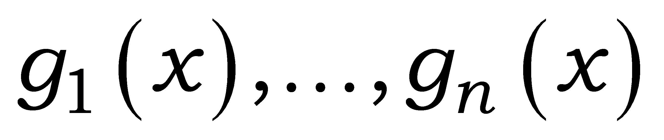 be differentiable functions. If 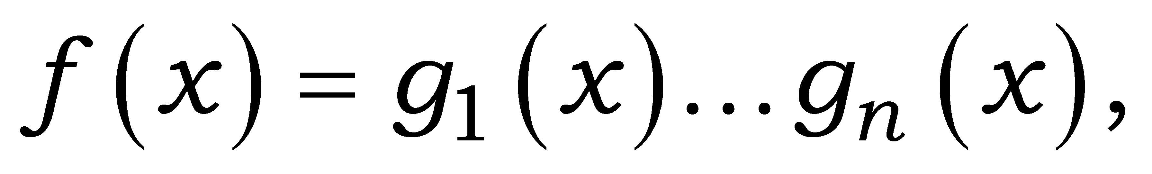prove that its derivative is 