Consider the following graph:

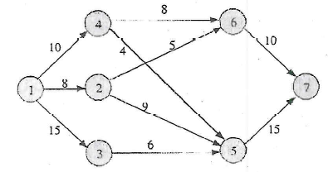

Use dynamic programming to find the longest path from node 1 to node 7.

What are the states and stages?

What is the recursive function?

