A small 6.3g plastic ball is suspended by a 28cm long string in a uniform electric field of 4400N/C in the +x direction. If the ball is in equilibrium when the string makes a 25.9 angle with the vertical, what is the net charge on the ball?

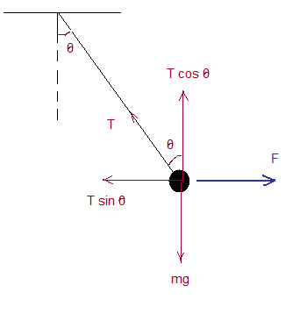
Assume that the tension on the rope is T.
Since the ball is at equilibrium, the net force on the ball is zero.
Hence, the net vertical force = 0 and the net horizontal force = 0
Vertical Direction: There are two forces on the y direction.
- A component of the tension force T cos θ
- Weight mg

Net force in the vertical direction is T cos θ – mg
T cos θ – mg = 0
T = mg/cos θ = 0.0063 *9.8/cos 25.9 = 0.069 N
T = 0.069 N
Horizontal Direction: There are two forces on the x direction.
- A component of the tension force T sin θ
- The electric force Eq = 4400 x q
Net horizontal force on the ball is T sin θ - 4400 q
T sin θ - 4400 q = 0
Solving for q,
q = T sin θ /4400 = 0.069 * sin 25.9 /4400 = 6.85 x 10⁻⁶ C
q = 6.85 μC

