1 Excel workbook
Consider the following scenario:
As supervisor for a retail company, you supervise six people in your location. You are responsible for their payroll and commissions each week. This task would normally take a couple of hours on paper, but you now have the expertise needed to automate the process by using formulas and functions in an Excel spreadsheet.
Use the data provided to create a worksheet described below:
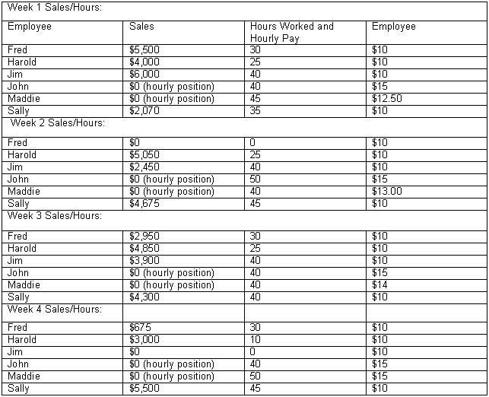
You must create a workbook with separate sheets for each week that would allow sales managers to compare sales figures and commissions from one week to the next. Each worksheet should calculate the payroll amount for each of your six employees. If sales are below $1,000, then the commission paid is 5% of the sales. If sales are between $1,000 and $3,999.99, the commission paid is 10% of the sales. If sales are $4,000 or higher, the sales person receives a 12.5% commission rate.

Sales people will be paid either their commission or hourly pay earned amount—whichever is higher. Hourly employees receive 150% of their hourly rate for any hours worked over 40 hours per week (time and a half for overtime worked).
Each worksheet should contain the following headings:
- Employee
- Sales
- Hours Worked
- Hourly Pay
- Commission Earned
- Hourly Pay Earned
- Payroll Amount
To complete this workbook, you must write specific formulas and functions. The Commission Earned, Hourly Pay Earned (for the two hourly employees), and Payroll Amount columns require you to use IF functions. Remember, the payroll amount for salespeople will be either the commission earned or hourly pay earned—whichever is greater. Do not calculate commission earned for hourly employees or overtime for sales employees (this is anyone who has a sales figure in the Sales column).

