Problem 13-1A
Ratios, common-size statements, and trend percents
Selected comparative financial statements of Bennington Company follow.
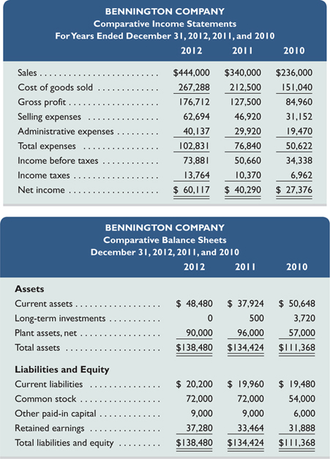
Required
- Compute each year's current ratio. (Round ratio amounts to one decimal.)
- Express the income statement data in common-size percents. (Round percents to two decimals.)
- Express the balance sheet data in trend percents with 2010 as the base year. (Round percents to two decimals.)
Check
(3) 2012, Total assets trend, 124.34%

Analysis Component
- Comment on any significant relations revealed by the ratios and percents computed.

Problem 13-4A
Calculation of financial statement ratios
Selected year-end financial statements of McCord Corporation follow. (All sales were on credit; selected balance sheet amounts at December 31, 2010, were inventory, $32,400; total assets, $182,400; common stock, $90,000; and retained earnings, $31,300.)
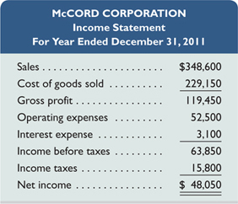
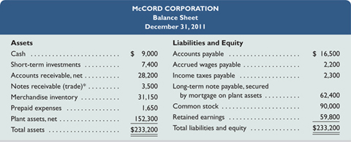
* These are short-term notes receivable arising from customer (trade) sales.
Required
Compute the following: (1) current ratio, (2) acid-test ratio, (3) days' sales uncollected, (4) inventory turnover, (5) days' sales in inventory, (6) debt-to-equity ratio, (7) times interest earned, (8) profit margin ratio, (9) total asset turnover, (10) return on total assets, and (11) return on common stockholders' equity.
Check
Acid-test ratio, 2.3 to 1: Inventory turnover, 7.2

