Problem 20-5A
Preparation of a complete master budget
Near the end of 2011, the management of Simid Sports Co., a merchandising company, prepared the following estimated balance sheet for December 31, 2011.
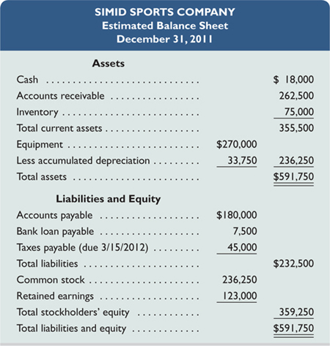
To prepare a master budget for January, February, and March of 2012, management gathers the following information.
- Simid Sports' single product is purchased for $30 per unit and resold for $55 per unit. The expected inventory level of 2,500 units on December 31, 2011, is more than management's desired level for 2012, which is 20% of the next month's expected sales (in units). Expected sales are: January, 3,500 units; February, 4,500 units; March, 5,500 units; and April, 5,000 units.
- Cash sales and credit sales represent 25% and 75%, respectively, of total sales. Of the credit sales, 60% is collected in the first month after the month of sale and 40% in the second month after the month of sale. For the December 31, 2011, accounts receivable balance, $62,500 is collected in January and the remaining $200,000 is collected in February.
- Merchandise purchases are paid for as follows: 20% in the first month after the month of purchase and 80% in the second month after the month of purchase. For the December 31, 2011, accounts payable balance, $40,000 is paid in January and the remaining $140,000 is paid in February.
- Sales commissions equal to 20% of sales are paid each month. Sales salaries (excluding commissions) are $30,000 per year.
- General and administrative salaries are $72,000 per year. Maintenance expense equals $1,000 per month and is paid in cash.
- Equipment reported in the December 31, 2011, balance sheet was purchased in January 2011. It is being depreciated over eight years under the straight-line method with no salvage value. The following amounts for new equipment purchases are planned in the coming quarter: January, $18,000; February, $48,000; and March, $14,400. This equipment will be depreciated under the straight-line method over eight years with no salvage value. A full month's depreciation is taken for the month in which equipment is purchased.
- The company plans to acquire land at the end of March at a cost of $75,000, which will be paid with cash on the last day of the month.
- Simid Sports has a working arrangement with its bank to obtain additional loans as needed. The interest rate is 12% per year, and interest is paid at each month-end based on the beginning balance. Partial or full payments on these loans can be made on the last day of the month. The company has agreed to maintain a minimum ending cash balance of $12,500 in each month.
- The income tax rate for the company is 40%. Income taxes on the first quarter's income will not be paid until April 15.
Required
Prepare a master budget for each of the first three months of 2012; include the following component budgets (show supporting calculations as needed, and round amounts to the nearest dollar):
- Monthly sales budgets (showing both budgeted unit sales and dollar sales).
- Monthly merchandise purchases budgets.
Check
(2) Budgeted purchases: January, $57,000; February, $141,000 (3) Budgeted selling expenses: January, $41,000; February, $52,000
- Monthly selling expense budgets.
- Monthly general and administrative expense budgets.
- Monthly capital expenditures budgets.
(6) Ending cash bal.: January, $15,050; February, $105,150
- Monthly cash budgets.
- Budgeted income statement for the entire first quarter (not for each month).
(8) Budgeted total assets at March 31, $784,325
- Budgeted balance sheet as of March 31, 2012.

Problem 21-6A^{A}
Materials, labor, and overhead variances; and overhead variance report
Kudos Company has set the following standard costs per unit for the product it manufactures.
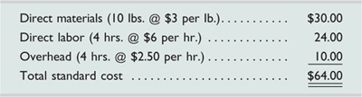
The predetermined overhead rate is based on a planned operating volume of 80% of the productive capacity of 10,000 units per month. The following flexible budget information is available.
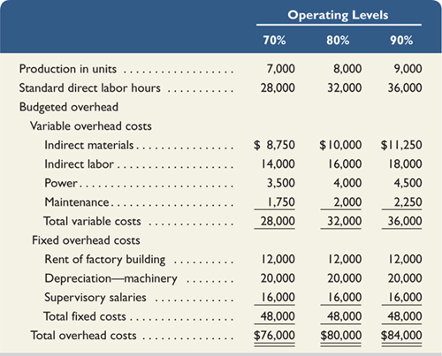
During May, the company operated at 90% of capacity and produced 9,000 units, incurring the following actual costs.
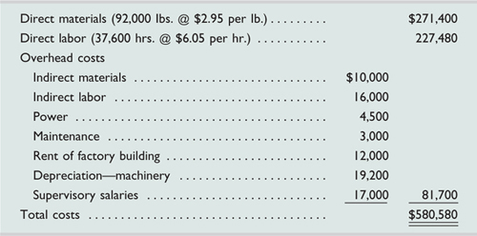
Required
Check
(1) Materials variances: Price, $ 4,600 F; Quantity, $ 6,000 U (2) Labor variances: Rate, $ 1,880 U; Efficiency, $ 9,600 U
- Compute the direct materials variance, including its price and quantity variances.
- Compute the direct labor variance, including its rate and efficiency variances.
- Compute these variances: (a) variable overhead spending and efficiency, (b) fixed overhead spending and volume, and (c) total overhead controllable.
- Prepare a detailed overhead variance report that shows the variances for individual items of overhead.

