Cost Behavior and Cost-Volume-Profit Analysis

Problem 18-1A
Contribution margin income statement and contribution margin ratio
The following costs result from the production and sale of 4,000 drum sets manufactured by Vince Drum Company for the year ended December 31, 2011. The drum sets sell for $250 each. The company has a 25% income tax rate.
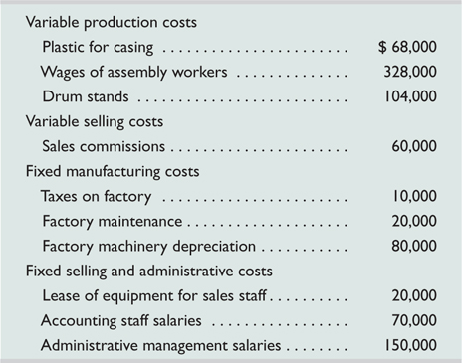
Required
- Prepare a contribution margin income statement for the company.
- Compute its contribution margin per unit and its contribution margin ratio.

Analysis Component
- Interpret the contribution margin and contribution margin ratio from part 2.
Check
(1) Net income, $67,500

Problem 18-4A
Break-even analysis; income targeting and forecasting
Jetson Co. sold 20,000 units of its only product and incurred a $50,000 loss (ignoring taxes) for the current year as shown here. During a planning session for year 2012's activities, the production manager notes that variable costs can be reduced 50% by installing a machine that automates several operations. To obtain these savings, the company must increase its annual fixed costs by $150,000. The maximum output capacity of the company is 40,000 units per year.
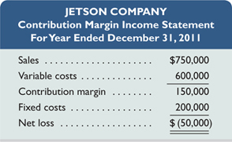
Required
- Compute the break-even point in dollar sales for year 2011.
- Compute the predicted break-even point in dollar sales for year 2012 assuming the machine is installed and there is no change in the unit sales price.
- Prepare a forecasted contribution margin income statement for 2012 that shows the expected results with the machine installed. Assume that the unit sales price and the number of units sold will not change, and no income taxes will be due.
- Compute the sales level required in both dollars and units to earn $140,000 of after-tax income in 2012 with the machine installed and no change in the unit sales price. Assume that the income tax rate is 30%. (Hint: Use the procedures in Exhibits 18.21 and 18.23.)
- Prepare a forecasted contribution margin income statement that shows the results at the sales level computed in part 4. Assume an income tax rate of 30%.
Check
(3) Net income, $100,000
(4) Required sales, $916,667 or 24,445 units

Problem 18-5A
Break-even analysis, different cost structures, and income calculations
Letter Co. produces and sells two products, T and O. It manufactures these products in separate factories and markets them through different channels. They have no shared costs. This year, the company sold 50,000 units of each product. Sales and costs for each product follow.
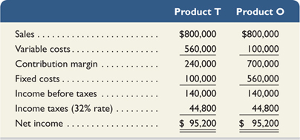
Required
- Compute the break-even point in dollar sales for each product.
- Assume that the company expects sales of each product to decline to 33,000 units next year with no change in unit sales price. Prepare forecasted financial results for next year following the format of the contribution margin income statement as just shown with columns for each of the two products (assume a 32% tax rate). Also, assume that any loss before taxes yields a 32% tax savings.
- Assume that the company expects sales of each product to increase to 64,000 units next year with no change in unit sales price. Prepare forecasted financial results for next year following the format of the contribution margin income statement shown with columns for each of the two products (assume a 32% tax rate).
Check
(2) After-tax income: T, $39,712; O, $(66,640)
(3) After-tax income: T, $140,896; O, $228,480

Analysis Component
- If sales greatly decrease, which product would experience a greater loss? Explain.
- Describe some factors that might have created the different cost structures for these two products.

