Problem 12-1A
Statement of cash flows (indirect method)
Kazaam Company, a merchandiser, recently completed its calendar-year 2011 operations. For the year, (1) all sales are credit sales, (2) all credits to Accounts Receivable reflect cash receipts from customers, (3) all purchases of inventory are on credit, (4) all debits to Accounts Payable reflect cash payments for inventory, and (5) Other Expenses are paid in advance and are initially debited to Prepaid Expenses. The company's balance sheets and income statement follow.
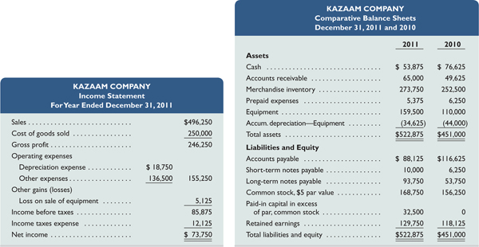
Additional Information on Year 2011 Transactions
- The loss on the cash sale of equipment was $5,125 (details in b).
- Sold equipment costing $46,875, with accumulated depreciation of $28,125, for $13,625 cash.
- Purchased equipment costing $96,375 by paying $25,000 cash and signing a long-term note payable for the balance.
- Borrowed $3,750 cash by signing a short-term note payable.
- Paid $31,375 cash to reduce the long-term notes payable.
- Issued 2,500 shares of common stock for $18 cash per share.
- Declared and paid cash dividends of $62,125.
Required
- Prepare a complete statement of cash flows; report its operating activities using the indirect method. Disclose any noncash investing and financing activities in a note.

Analysis Component
- Analyze and discuss the statement of cash flows prepared in part 1, giving special attention to the wisdom of the cash dividend payment.

Check
Cash from operating activities, $33,375

Problem 12-3A^{A}
Cash flows spreadsheet (indirect method)
Refer to the information reported about Kazaam Company in Problem 12-1A.
Required
Prepare a complete statement of cash flows using a spreadsheet as in Exhibit 12A.1; report its operating activities using the indirect method. Identify the debits and credits in the Analysis of Changes columns with letters that correspond to the following list of transactions and events.
- Net income was $73,750.
- Accounts receivable increased.
- Merchandise inventory increased.
- Prepaid expenses decreased.
- Accounts payable decreased.
- Depreciation expense was $18,750.
- Sold equipment costing $46,875, with accumulated depreciation of $28,125, for $13,625 cash. This yielded a loss of $5,125.
- Purchased equipment costing $96,375 by paying $25,000 cash and (i.) by signing a long-term note payable for the balance.
- Borrowed $3,750 cash by signing a short-term note payable.
- Paid $31,375 cash to reduce the long-term notes payable.
- Issued 2,500 shares of common stock for $18 cash per share.
- Declared and paid cash dividends of $62,125.
Check
Analysis of Changes column totals, $515,375

