2.)
Consider the following IP problem:
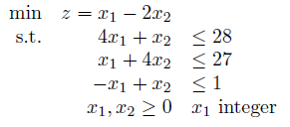

Use branch and bound algorithm to solve this problem by hand. For each subproblem, solve its LP relaxation graphically.

