Problem 11-1A
Stockholders' equity transactions and analysis
Oxygen Co. is incorporated at the beginning of this year and engages in a number of transactions. The following journal entries impacted its stockholders' equity during its first year of operations.
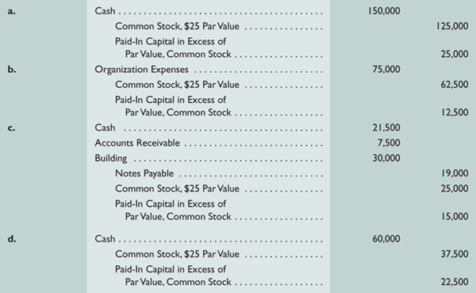
Required
Explain the transaction(s) underlying each journal entry (a) through (d).
- How many shares of common stock are outstanding at year-end?
- What is the amount of minimum legal capital (based on par value) at year-end?
- What is the total paid-in capital at year-end?
- What is the book value per share of the common stock at year-end if total paid-in capital plus retained earnings equals $347,500?
Check
(2) 10,000 shares
(3) $250,000
(4) $325,000

Problem 11-1B
Stockholders' equity transactions and analysis
Nilson Company is incorporated at the beginning of this year and engages in a number of transactions. The following journal entries impacted its stockholders' equity during its first year of operations.
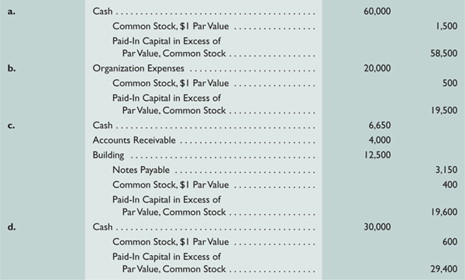
Required
- Explain the transaction(s) underlying each journal entry (a) through (d).
- How many shares of common stock are outstanding at year-end?
- What is the amount of minimum legal capital (based on par value) at year-end?
- What is the total paid-in capital at year-end?
- What is the book value per share of the common stock at year-end if total paid-in capital plus retained earnings equals $141,500?
Check
(2) 3,000 shares
(3) $3,000
(4) $130,000

