1.
(Points: 10)
Rierson Inc. produces and sells two products. Data concerning those products for the most recent month appear below:
The fixed expenses of the entire company were $17,730. The break-even point for the entire company is closest to:
- a. $32,250
- b. $17,730
- c. $31,661
- d. $15,270

3.
(Points: 10)
Forest Corporation has prepared the following budgeted data based on a sales forecast of $3,000,000:
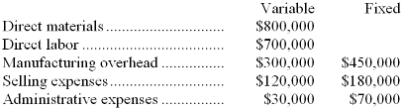
What would be the amount of dollar sales at the break-even point?
- a. $1,125,000
- b. $2,000,000
- c. $2,650,000
- d. $1,750,000

4.
(Points: 10)
Hilty Corporation produces and sells two products. In the most recent month, Product U77D had sales of $45,000 and variable expenses of $15,750. Product D86D had sales of $49,000 and variable expenses of $22,790. And the fixed expenses of the entire company were $46,170. The break-even point for the entire company is closest to:
- a. $47,830
- b. $84,710
- c. $46,170
- d. $78,254

6.
(Points: 10)
Riven Corporation has a single product whose selling price is $10. At an expected sales level of $1,000,000, the company's variable expenses are $600,000 and its fixed expenses are $300,000. The marketing manager has recommended that the selling price be increased by 20%, with an expected decrease of only 10% in unit sales. What would be the company's net operating income if the marketing manager's recommendation is adopted?
- a. $132,000
- b. $290,000
- c. $180,000
- d. $240,000

7.
(Points: 10)
Terres Corporation produces and sells a single product. Data concerning that product appear below:
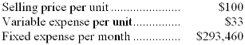
The break-even in monthly dollar sales is closest to:
- a. $889,273
- b. $438,000
- c. $293,460
- d. $540,244

