1. Given the diagram below, find P⋃Q. Write in correct set notation.
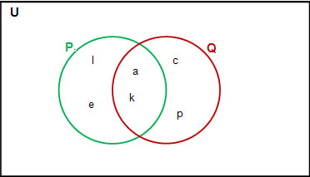

2. Given U = {15, 16, 17, 18, 19, 20, 21, 22, 23, 24, 25}, A = {15, 17, 21, 23, 25}, and B = {16, 17, 18, 22, 25}. Find A′⋃ B’. finding A’, then B’ then find their union.

3. Using correct mathematical notation and symbols, express the following in set-builder notation: Z = {4, 5, 6, 7, 8, 9, 10, 11}

4. A survey of flower gardeners showed the following:
45 grew roses 7 grew both roses and tulips 4 grew all three types
16 grew tulips 5 grew both orchids and tulips 9 grew none of these three
13 grew orchids 10 grew both roses and orchids
How many grew only roses?
(a) How many grew only roses
(b) How many grew both roses and tulips, but not orchids?
(c) How many grew only tulips?
(d) How many grew none of these three or only orchids?
(e) How many flower gardeners were surveyed?
Create a Venn diagram to reflect the above data.

5.Given A = {1,2,3}, B = {1,2,3,4,5}, and C = { 4, 5, 6, 7}. Evaluate each set
a) A ∩ B
b) A U C
c) B U C
d) (A U B) ∩ C
e) A U (B U C)
f) (A ∩ B) ∩ C
g) (A ∩ B) U C

