Week 3 Homework Robert Nelson
Chapter 5: Problem 8
8. The following represents a process used to assemble a chair with an upholstered seat. Stations A, B, and C, make the seat; stations J, K, and L assemble the chair frame; station X is where the two subassemblies are brought together; and some final tasks are completed in stations Y and Z. One worker is assigned to each of the stations. Generally, there is no inventory kept anywhere in the system, although there is room for one unit between each of the stations that might be used for a brief amount of time.

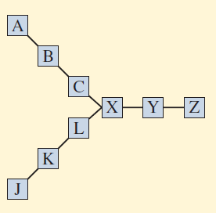

Given the following amount of work in seconds required at each station:

A 38 J 32 X 22
B 34 K 30 Y 18
C 35 L 34 Z 20

a. What is the possible daily output of this “process” if 8 hours of processing time is available each day?

b. Given your output rate in part a, what is the efficiency of the process?
c. What is the throughput time of the process?

