Variation in two polymorphic species of ladybird beetles
This piece of coursework is worth 25%
There are about 45 species of ladybird beetle (Coccinellidae) native to the British Isles. Two of the commonest species are Adalia bipunctata (A. 2-punctata) and Adalia decempunctata (A. 10-punctata). Both are highly polymorphic with numerous morphs named. Most of the morphs are determined by an allelic series at a single locus but epistatitically acting genes are also involved.
The commonest morphs of Adalia bipunctata in the British Isles are shown below.
- Sublunata
- Quadrimaculata
- Sexspustulata
- Typica
- Stephensii
- Rubiginosa
- Unifasciata
- Annulata
- 12-pustulata

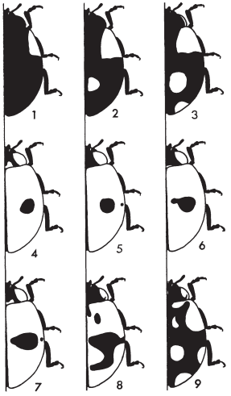
The distribution of these morphs has been studied by many workers both in Britain and elsewhere: in relation to climate, pollution, predation and habit preference. In practice many workers have aggregated rare morphs with more common types to ease the scoring and analysis of fewer classes: recognising classes such as a “typical” class (black spots on a red background) and a melanic class (red spots on a black background). Some have recognised an intermediate class where the two main spots have expanded to form a ring (sometimes called annulata) – for example lumping together types 6, 7 and 8 shown above).

A similar range of morphs has also been described in Adalia 10-punctata though again these are often lumped together in a “typical” class, a “melanic” class and intermediate “checqered” classes may also be recognised.

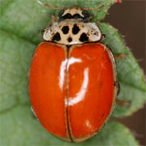 | 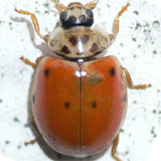 | 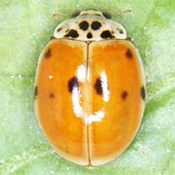 | 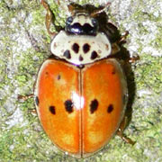 | 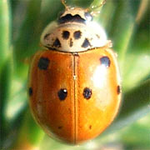
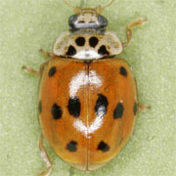 | 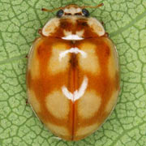 | 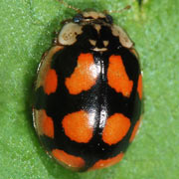 | 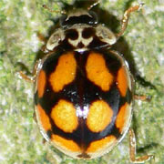 | 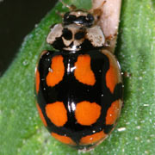
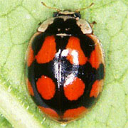 | 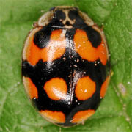 | 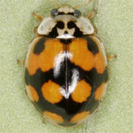 | 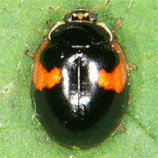

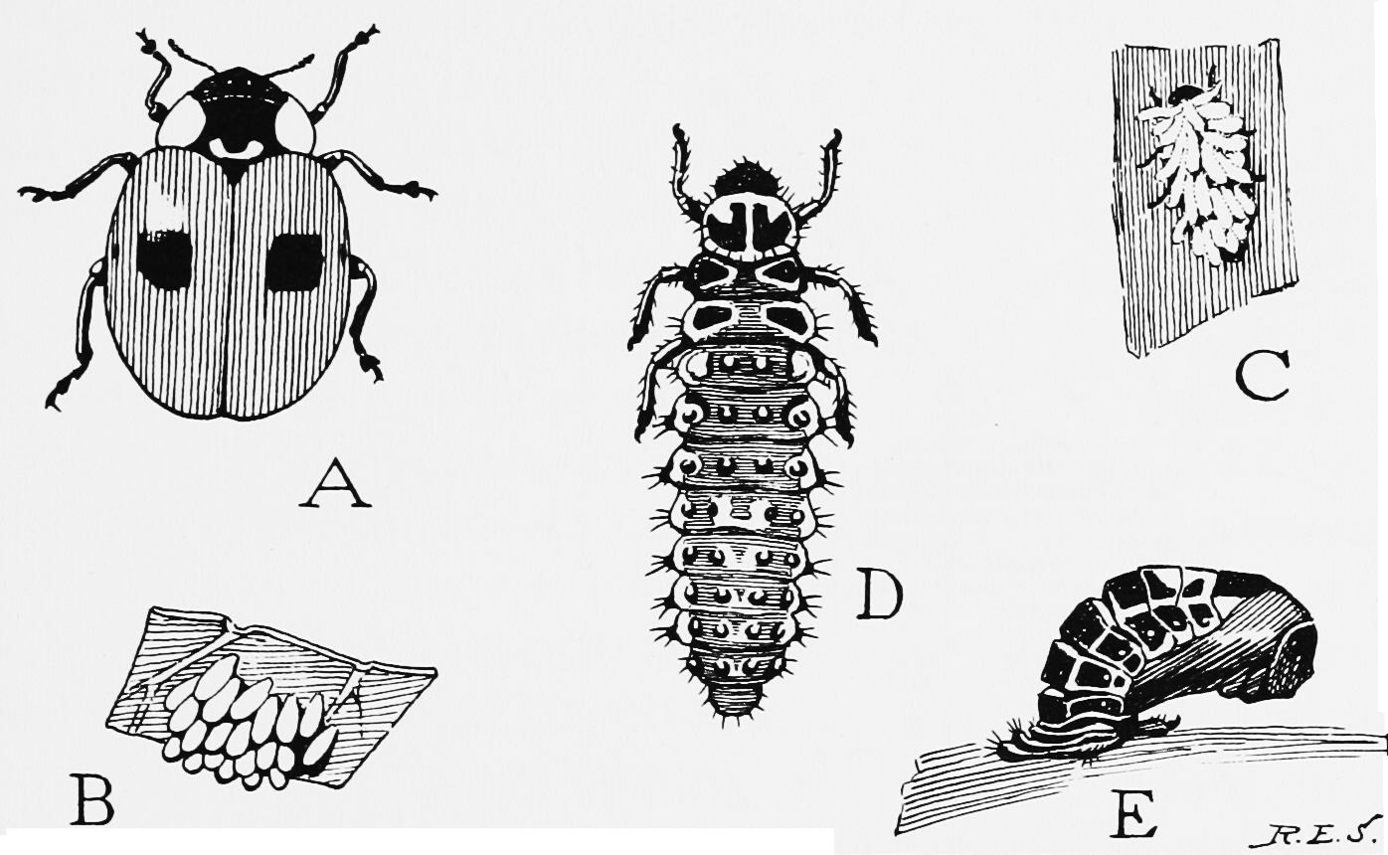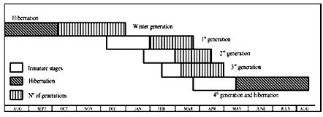
Overwintering adults disperse in spring and oviposition occurs. 2-3 overlapping generations can be produced each year.
You are presented with some primary data for these two species randomly sampled from four different localities and a variety of habitats at a number of different dates. Your task is to use this data to examine TWO different scientific questions that you choose about the patterns of variation exhibited by these species. To give you an idea here are some possibile scientific questions ( you may think of others you would like to explore!)
- Do the species differ in size?
- Do the species differ in the frequency of typical and melanic individuals?
- Do the species have different habitat preferences?
- Do the sexes differ in size and/or morph distribution?
- What is the relationship between size and melanism?
- Are different morphs associated with particular habitats?
- Are environmental factors associated with the patterns of variation in size and morph type?
- What is a better measure of size?
- Is it possible to predict sex from the size of beetle?

Format
5-8 x A4 pages - each page including the following sections
- A statement of which TWO scientific hypothesis or hypotheses that you want to examine using this data. (Of course normally in a scientific investigation you would state the hypothesis before collecting the data!)
1 page A4
- Relevant tables of summary statistics:
1-2 pages A4
- Relevant exploratory figures and graphs:
1-2 pages A4
- Appropriate statistical tests of difference or association
2-3 pages A4
You will gain marks for:
- clearly stating the hypotheses (remember a hypothesis is a statement not a question)
- summarising and tabulating the data RELEVANT to the hypotheses effectively
- carrying out and presenting the analysis of RELEVANT statistical comparisons and or statistical tests effectively and correctly
- analysing both categorical and continuously varying data
- presenting the results in CLEAR and USEFUL graphs
- following the instructions about format and length

What you are producing is the equivalent of a results section of a scientific paper and as such it should include only the minimum text required to explain the tables and figures (which will have proper table headings or figure legends).

DO NOT provide an introduction or methods section.
DO NOT provide a discussion
DO NOT provide references
DO NOT exceed 8 pages of A4
Present your report as a paper copy and as an electronic version. The electronic version should include a copy of your data set as an SPSS .save file and an edited version of the SPSS output. Submit these through Blackboard. Put your name on every page.
Each section (A-D) will contribute 5% to your module mark and 5% will be presented for overall scientific presentation and originality.

Data
Sampling date
Sampling took place in the same week in July in 1965.
Locality |  | Sunshine - monthly hours |  |  | Mean temperature °C
 |  | January | April | July | January | April | July
High Peak | Rural | 34 | 130 | 170 | 0 | 2.5 | 11
Salford | Urban | 44 | 135 | 180 | 5 | 8 | 17.5
Warrington | Industrial | 48 | 140 | 185 | 4 | 9 | 16.5
Formby | Coastal | 56 | 170 | 200 | 5 | 9 | 15

Sex

Individuals were kept under continuous light in petri dishes (-5/dish) and fed daily on live aphids. Petri dishes were changed every 2-3 days. All ladybirds were sexed by putting many individuals together in a Perspex box [about 30 (1) x 15 (w) x 15 cm (h)] and removing mating pairs (males on top!). Over 95% of ladybirds mated during sexing.
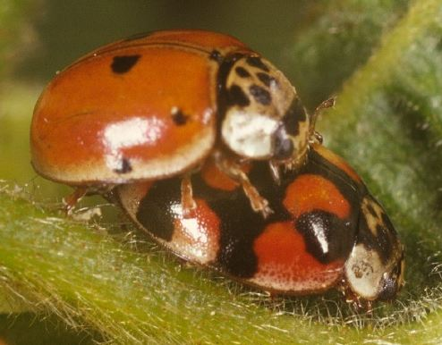

Habitat
Ladybirds were sampled from 5 different species of plant: Tilia X europaea (Lime trees), Sambucus nigra (Elder), Urtica dioica (Nettles), Rosa canina (Dog rose), Salix sp. (Sallow).

