Hi. Can someone please show me how to do the following problem? Thank you

The diffraction pattern shown in Figure 28-38 is produced by passing He-Ne laser light ( = 632.8 nm) through a single slit and viewing the pattern on a screen 1.00 m behind the slit. What is the width of the slit?

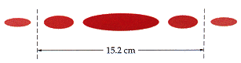
Figure 28-38

