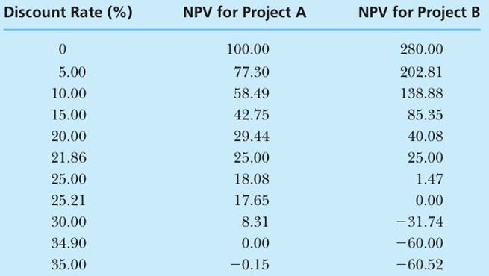

Using the table listed above identify the “crossover point” AND briefly describe the significance when the crossover rate is greater than the cost of capital for mutually exclusive projects. Why is the IRR method less reliable when evaluating mutually exclusive projects?

