.

**Part 1 – Online Calculator**

Go to http://www.calculator.org/jcalc98.html. This site requires no download. It allows you to copy and paste the answers from the calculator as well, which is a great feature when working on your projects. An alternate website is http://www.sci.wsu.edu/math/math107. Let’s practice using the calculator. We will do the following problems: 

1) **How to enter -2:**

Enter the 2, then press the +/- button to change it to a -2.

**2) How to obtain the answer to** 82**:**

Press 2 8 = *ax*

You must always press the = button after you enter an expression.

Did you get 256? If not, try again.

You should press the red AC button after each expression to clear the memory of the calculator.

Reminders:

Always press the red AC button to begin a new calculation. This clears the memory.

Always put parentheses around fractions. For example, (2/3).

Always press the = button after you enter the expression.

**How to graph in MS Excel and copy your graph to MS Word (Word 2007)**

**An example of a line and parabola are included.**

You should have at least 3 points ready to enter into MS Excel. Suppose I want to graph y=3x-2. Because this will be a line, I just need to find 3 points to enter in. Other graphs, such as parabolas, will require more points.

If x=0, y=3(0)-2 = -2. Therefore, (0,-2) is a point on the graph.

If x=1, y=3(1)-2=1 (1,1) is an additional point on the graph.

If x=2, y=3(2)-2=4 (2,4) is an additional point on the graph.

Let’s plot the points (0,-2), (1,1) and (2,4) and connect them with a line! You should always enter values in column A in increasing order, because that is the order they will be connected in MS Excel.

Open up MS Excel.

Enter in the points above as follows. Use your arrow keys to move between cells.

Highlight all of the values with your mouse:

Click on Insert and then on Scatter

Then select the graph in the top right:

You should then see the graph:

To add labels to the x and y axes, click on the first layout under Chart Layouts:

Then click on the Chart Title to edit it. Click on the axes titles to edit them as well. Suppose x is time in days and y is the value of stock. Let’s enter in labels. For the horizontal Axis Title, type in “Time in Days” and for the vertical Axis Title, type in Value of Stock.

**How to copy and paste this into MS Word:**

Click on your graph in the white chart area. Then right click and select Copy.

Open up MS Word. Click your mouse where you want the graph to go in MS Word , right click, and select paste: Now, lets try a parabola. Suppose we have the equation *y* = 2*x*2 − 3. We will need to plot a few positive numbers and a few negative numbers to see if we then have enough to make the “u-shape”.

Plug in -2, -1, 0, 1, and 2 to find the corresponding y values.

x = -2, y=2(-2)^2-3=2(4)-3=5

x=-1, y=2(1)^2-3=2(1)-3=-1

x=0, y=2(0)^2-3=0-3=-3

x=1, y=2(1)^2-3=2(1)-3=-1

x=2, y=2(2)^2-3=2(4)-3=5

Therefore, we will plot (-2,5) , (-1,-1), (0,-3), (1,-1), (2,5)

Open up MS Excel, enter in the points, and highlight them with your mouse.

Click on Insert. Then click on Scatter and be sure to select the graph in the top right.

Click on the first layout under Chart Layouts to add titles. Click on the Chart Title and Axis Titles to add labels.

Copy and paste this into MS Word by following the instructions above for the linear example

WORD 2007 -

MATH SYMBOLS AND EQUATIONS

Your new WORD 2007 has some great tools for helping you input math symbols and math equations into your assignment or word document! On the next few pages, you will see screens and instructions for how to input various math symbols and equations into your assignment or word document.

If you ever have questions how to input a symbol or an equation, you can always press your F1 key and request how to **WRITE OR INSERT AN EQUATION** or **INSERT MATHEMATICAL SYMBOLS**. You do this by typing in either **WRITE OR INSERT AN EQUATION** or **INSERT MATHEMATICAL SYMBOLS** in the search box of the F1 screen.

You will see one of the following two screens:

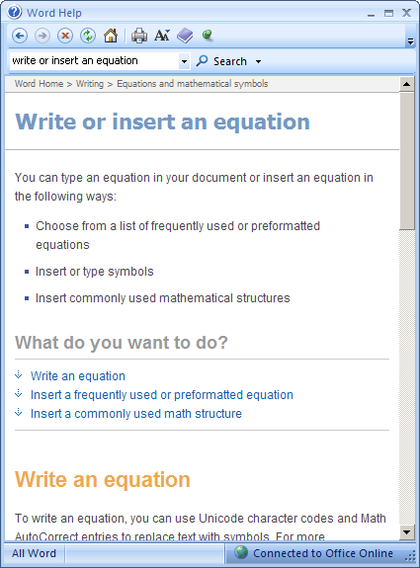

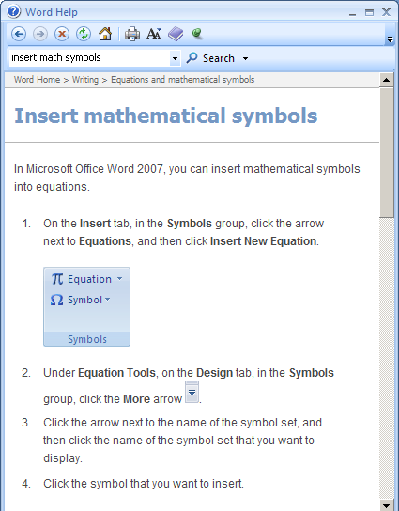

**Setting Up your Quick Access Toolbar:**

1. Right click on the word **Home** in the upper left-hand corner of our computer screen of WORD 2007.
2. Left click on **Customize Quick Access Toolbar**.
3. Click on the drop box for **Choose Commands from** and select **ALL COMMANDS**.
4. Then, under **<Separator>**, select **Equation Symbols**Type equation here. for inserting the **Equations Symbols’** logo, **∞.**
5. Left click on **ADD**, located in the middle of the screen..
6. Left click on **OK**, located at the bottom of the screen.
7. Then, under **<Separator>**, select **Equations Options** for inserting the **Equations Options’** logo, **π** .
8. Left click on **ADD**, located in the middle of the screen..
9. Left click on **OK**, located at the bottom of the screen.

**A screen shot of this page is shown below.**

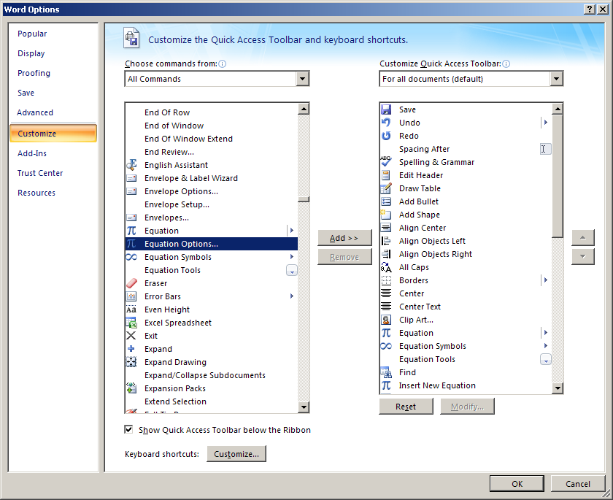

**Accessing Equation Options:**

1. To quickly access Equations Options, first click on the **ALT** key , and then while holding that key down, press the $\begin{matrix}+ \\ =\end{matrix}$ key .
2. You will see the following screen displayed.

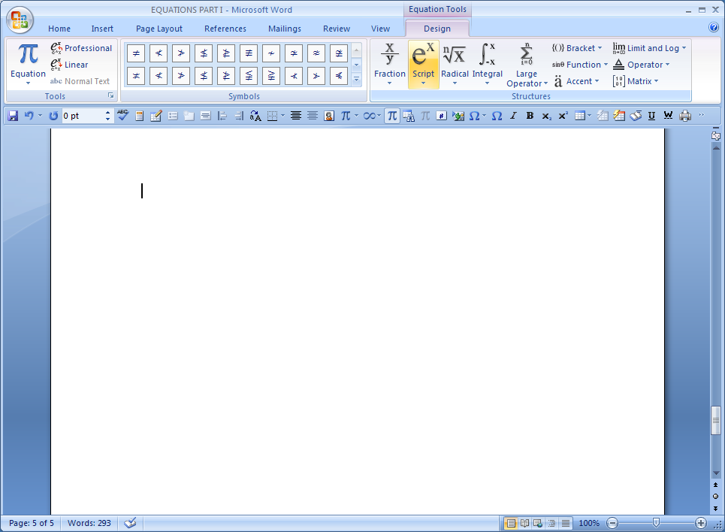

1. **Various Activities in Equations Options:**

**After clicking on the ALT key and holding it down while you press the**

$\begin{matrix}+ \\ =\end{matrix}$ key:

1. You can create a fraction, by first clicking on the **FRACTION** option in the upper middle section of the computer display. Select the desired format for your fraction and click on it. Then, after it is transferred over to your word document, type in the desired numbers or letters in the dotted boxes of the fraction.

Type equation here. EXAMPLE:

To type in the fraction $\frac{4}{5}$:

1. Click on the word Fraction in the upper middle section of your computer display.
2. Select and click on .
3. Then, type in the 4 in the top dotted box. $\frac{4}{}$
4. Next, type in the 5 in the bottom dotted box. $\frac{4}{5}$.
5. You can create a radical, by first clicking on the **RADICAL** option in the upper middle section of the computer display. Select the desired format for your radical and click on it. Then, after it is transferred over to your word document, type in the desired numbers or letters in the dotted box(es) of the radical.

EXAMPLE:

To type in $\sqrt{11}$:

1. Click on the word Radical in the upper middle section of your computer display.
2. Select .
3. Then, type in 11 in the dotted box. $\sqrt{11}$.

Note, to type **CUBEROOT**, click on RADICAL and then click on the 2nd option: . Use the arrow keys to type the index and the radicand. For example, $\sqrt[3]{5 }$

1. To type the **QUADRATIC FORMULA** click on RADICAL and select the one on the bottom left under “Common Radicals” $\frac{-b±\sqrt{b^{2}-4ac}}{2a}$. You can then edit this as needed.

1. To type **EXPONENTS** click on Script and select . Use the arrow keys to alternate between the base and exponent and type them in. For example, $2^{3}$

1. You can create an integral, by first clicking on the **INTEGRAL** option in the upper middle section of the computer display. Select the desired format for your integral and click on it. Then, after it is transferred over to your word document, type in the desired numbers or letters in the dotted box(es) of the integral.

EXAMPLE:

To type in $\int_{0}^{2}{x dx}$:

1. Click on the word Integral in the upper middle section of your computer display.
2. Select .
3. Then, type in the numbers and letters in the respective dotted boxes. $\int_{0}^{2}{x dx}$.
4. You can create an absolute value expression, by first clicking on the **BRACKETS** option in the upper right-hand corner section of the computer display. Select the desired format for your absolute value expression and click on it. Then, after it is transferred over to your word document, type in the desired numbers or letters in the dotted box of the absolute value expression.

EXAMPLE:

To type in $\left|-5\right|$:

1. Click on the word Brackets in the upper right-hand corner section of your computer display.
2. Select .
3. Then, type in the numbers and letters in the dotted box. $\left|-5\right|$.
4. You can type in the $\boxed{a^{2}=b^{2}+c^{2}}$ equation or other accents to your desired equation or expression, by first clicking on the **ACCENTS** option in the upper right-hand corner section of the computer display. Select the desired equation and click on it. Then, after it is transferred over to your word document, you are finished.

1. You can create a logarithmic expression, by first clicking on the **LIMIT and LOG** option in the upper right-hand corner section of the computer display. Select the desired format for your logarithmic expression and click on it. Then, after it is transferred over to your word document, type in the desired numbers or letters in the dotted box of the logarithmic expression.

EXAMPLE:

To type in $\log{(x+2)}$:

1. Click on the words LIMIT AND LOG in the upper right-hand corner section of your computer display.
2. Select $\log{}$.
3. Then, type in the parentheses, plus sign, number and letter in the dotted box. $\log{(x+2)}$.
4. You can create an if…then.. or yields, or any statement containing arrows, by first clicking on the **OPERATOR** option in the upper right-hand corner section of the computer display. Select the desired format for your statement and click on it. Then, after it is transferred over to your word document, type in the desired numbers or letters in the dotted box(es) of the statement.

EXAMPLE:

To type in (4 + 3) $\underset{→}{yields}$ 7 :

1. Click on the word Operator in the upper right-hand corner section of your computer display.
2. Select $\underset{→}{yields}$.
3. Then, type in the parentheses, plus sign, and numbers before and after the yields symbol.

(4 + 3) $\underset{→}{yields}$ 7

1. You can create a matrix, by first clicking on the **BRACKETS** option in the upper right hand corner of the computer display. Select the desired format for your bracket and click on it. It is important to make sure your curser is inside the brackets. Then click on the **MATRIX** option in the upper right hand corner of the computer display. In the **EMPTY MATRICES** portion, select the size of the matrix needed. Once the matrix is transferred over to your word document, type in the desired numbers or letters in the dotted boxes.

EXAMPLE:

To type $\left[\begin{matrix}1 & 12 \\ 10 & 3\end{matrix}\right]$

1. Click on the word Brackets in the upper right hand corner section of your computer display.
2. Select
3. Make sure your curser is inside the brackets.
4. Click on the Matrix option in the upper right hand corner section of your computer display, and then choose from the Empty Matrices portion.
5. Then, type in the numbers in the dotted boxes $\left[\begin{matrix}1 & 12 \\ 10 & 3\end{matrix}\right]$.
6. You can type trigonometric functions and expressions as well. You will need to click the FUNCTIONS option in the upper right hand corner of the equation editor menu bar. Then select the desired trig function.  
   EXAMPLE:  
   To type a trig identity such as   
   a) Click Functions and select sin  
   b) See item 4 above to type the exponents  
   c) type the + character from the keyboard  
   d) Click Functions and select cos  
   e) See item 4 above to type the exponents  
   f) type = 1 from the keyboard.
7. **Various Activities in Equations Symbols:**

**After clicking on the ∞ symbol on your Quick Access Toolbar:**

1. You can create an equation with a plus/minus symbol or any other Basic Math type symbol , by first clicking on the Basic Math table of symbols displayed after clicking on the ∞ symbol and then selecting the ± symbol. If the Basic Math symbols are not presently displayed, click on the drop box up at the top of the ∞’s computer display, and select Basic Math.

EXAMPLE:

To type in x = ± 4 :

1. Type x .
2. Type = .

x =

1. Click on the Basic Math table of symbols displayed after clicking on the ∞ symbol and then selecting the ± symbol. If the Basic Math symbols are not presently displayed , click on the drop box up at the top of the ∞’s computer display, and select Basic Math.

x = ±

1. Type in 4.

x = ± 4

1. You can create an expression that contains the π symbol , by first clicking on the Basic Math table of symbols displayed after clicking on the ∞ symbol and then clicking on the drop box up at the top of the computer display for the Equation Symbols and select Greek Letters. If the Basic Math symbols are not presently displayed , click on the drop box up at the top of the ∞’s computer display, and select Greek Letters.

EXAMPLE:

To type in 3π :

1. Type 3 .
2. Click on the Basic Math table of symbols displayed after clicking on the ∞ symbol and then click on the drop box up at the top of the computer display for the Equation Symbols and select Greek Letters. If the Basic Math symbols are not presently displayed , click on the drop box up at the top of the ∞’s computer display, and select Greek Letters.
3. Click on the π symbol.

3π

1. You can create an expression that contains an operator symbol such as greater than or equal to , ≥, by first clicking on the Basic Math table of symbols displayed after clicking on the ∞ symbol and then clicking on the drop box up at the top of the computer display for the Equation Symbols and select Operators. If the Basic Math symbols are not presently displayed , click on the drop box up at the top of the ∞’s computer display, and select Operators. Then select the desired operator symbol.

EXAMPLE:

To type in x ≥ 7 :

1. Type x .
2. Click on the Basic Math table of symbols displayed after clicking on the ∞ symbol and then click on the drop box up at the top of the computer display for the Equation Symbols and select Operators. If the Basic Math symbols are not presently displayed , click on the drop box up at the top of the ∞’s computer display, and select Operators.
3. Click on the ≥ symbol.

x ≥

1. Type 7 .

x ≥ 7

1. You can create an expression that contains an arrow symbol , by first clicking on the Basic Math table of symbols displayed after clicking on the ∞ symbol and then clicking on the drop box up at the top of the computer display for the Equation Symbols and select Arrows. If the Basic Math symbols are not presently displayed , click on the drop box up at the top of the ∞’s computer display, and select Arrows. Then select the desired arrow symbol.

EXAMPLE:

To type in p → q :

1. Type p .
2. Click on the Basic Math table of symbols displayed after clicking on the ∞ symbol and then click on the drop box up at the top of the computer display for the Equation Symbols and select Arrows. If the Basic Math symbols are not presently displayed , click on the drop box up at the top of the ∞’s computer display, and select Arrows.
3. Click on the → symbol.

p →

1. Type q , and the result will be: p → q
2. You can create an expression that contains a Geometry symbol, by first clicking on the Basic Math table of symbols displayed after clicking on the ∞ symbol and then clicking on the drop box up at the top of the computer display for the Equation Symbols and select Geometry. If the Basic Math symbols are not presently displayed , click on the drop box up at the top of the ∞’s computer display, and select Geometry. Then select the desired Geometry symbol.

EXAMPLE:

To type in m ⊥ n :

1. Type m .
2. Click on the Basic Math table of symbols displayed after clicking on the ∞ symbol and then click on the drop box up at the top of the computer display for the Equation Symbols and select Geometry. If the Basic Math symbols are not presently displayed , click on the drop box up at the top of the ∞’s computer display, and select Geometry.
3. Click on the ⊥ symbol.

m ⊥

1. Type n .

m ⊥ n

3) A temporary agency offers two payment options for administrative help:

Option1: $25 daily fee plus $10/hour; or

Option 2: No daily fee but $15/hour.

Let *x* = total hours worked.

1. Write a mathematical model representing the total temp cost, *C*, for a **four**-day temporary administrative assistant in terms of *x* for the following:

Option 1: *C*=_________________

Option 2: *C*=_________________

How many total hours would the temp need to work in the four-day period for the cost of Option 1 to be less than Option 2. Set up an inequality and show your work algebraically using the information in part a). Don’t forget about the daily fee in Option 1 (it’s a four-day proposition!).

Answer:

Show your work here:

1. Summarize your findings in a brief sentence.

Answer:

4) Graph the equations by completing the tables and plotting the points on separate

graphs. You may use Excel or another web-based graphing utility.

1. Complete the table using the given values of x and the equation y = 2x – 5**.** Show your work.

|  |  |
| --- | --- |
| x | y |
| -1 | |
| 1 | |
| 3 | |