Sec 12.6 #40
TWO Spins: assume that the pointer cannot land on the line and that each spin is independent.
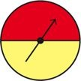

40) Red and then yellow.

Sec 12.9 #12
Evaluate the expression.

