Present and Future Value ;
Now consider an irregular cash flow stream (where CFs can take on any value).
- Calculate the Present Value of the Uneven Cash Flows. Interest Rate = 10%
T=0 | T=1 | T=2 | T=3 | T=4 | T=5
$0 | $100 | $300 | $300 | $300 | $500

- Calculate the Future Value of the Uneven Cash Flows.Interest Rate = 12%
T=0 | T=1 | T=2 | T=3 | T=4 | T=5
$0 | $100 | $300 | $300 | $300 | $500

- Assume that an investment with the following positive cash flows has a cost of $957.90 (outflow). Find the rate of return on this investment.
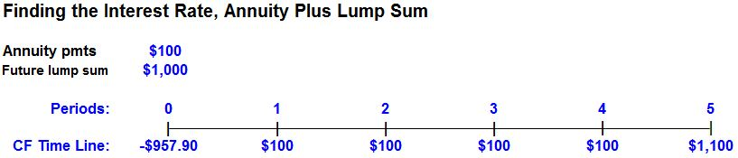

- How many years does it take for an investment to double if the interest rate is 1.25%?

