Ratio Analysis
  - Calculate the 3 stage DuPont equation for Williams Corporation given the following 2007 information:

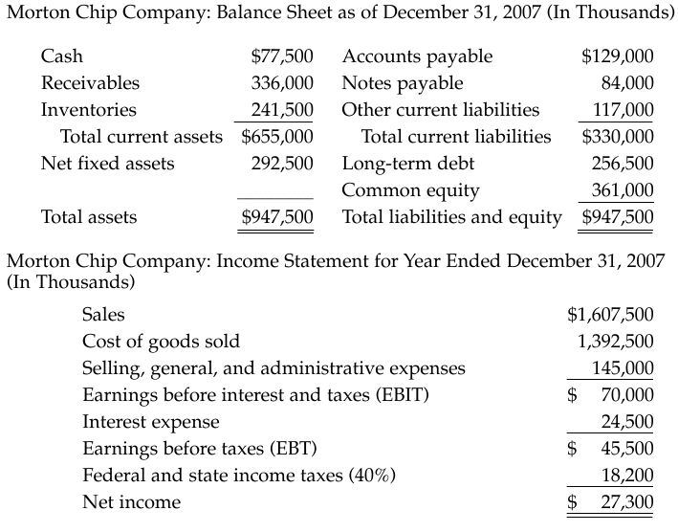

  - Discuss at least 3 qualitative factors that should be considered when analyzing a company’s financial performance.

