Scenario/Summary
The Columbia Lumber Products Company (CLPC) was headquartered in Portland, Oregon, where it had been founded in 1899. For many years, its principal product had been only lumber; in the 1940s it began producing plywood, and in 1960, particle board. The first two products, lumber and plywood, were produced at various sites in Oregon, and marketed on the West Coast and as far east as Chicago.
Particle board was produced in Duluth, Minnesota, at a plant built in 1962 with a U.S. Area Redevelopment Administration Loan. Initially, the input to the plant was trimmings and other scrap from CLPC’s Oregon operations. Particle board sales increased so quickly that the Duluth operation consumed not only all of the former waste from CLPC’s Oregon plant but also waste purchased from various lumber and wood products operations in Minnesota and northern Wisconsin.
In terms of product volume, CLPC’s sales doubled between 1960 and 1990. However, nearly all the growth had been in particle board; lumber and plywood sales remained relatively constant (though varying with changes in the home construction industry). In 1996, exports accounted for 9% of CLPC’s sales. Nearly all of this was plywood sold to Japan. Fifteen percent of CLPC’s 1996 purchases were from foreign sources, 5% was mahogany from the Philippines used for plywood veneer, and 10% was wood scrap purchased from Ontario, Canada, for use in CLPC’s Duluth plant. Particle board produced in Duluth was marketed in all states east of the Rocky Mountains, although sales in the southern United States were somewhat less than spectacular.
The slowdown in home production, which started in the late 1970s in the Midwest, really never ended and resulted in many years of little or no growth in CLPC’s sales. Common stock dividends had been cut several times. In 1996, they were 37 cents per share, down considerably from their peak—in 1976—of $2.21.
Stockholders, the outside directors, and various lending institutions were becoming increasingly unhappy. After a long, tense board of directors meeting, agreement was reached only with respect to what some of the organizational problems were. A partial list follows.
- The corporate headquarters was in Portland, although all growth occurred in the Midwest. Possibly, the headquarters, or at least more functions, should be shifted to an office in Duluth where the plant was, or to Chicago, the largest sales office. A major relocation away from Portland would be difficult. Many employees would choose to remain on the West Coast. Even for those willing to relocate, there was a split between those willing to relocate to Duluth and those willing to relocate to Chicago.
- There were too many vice presidents (see Exhibit 14-A). Because four vice presidents (engineering, finance, human resources, and purchasing) would reach mandatory retirement age by 1997, the number of vice presidents should be reduced from nine to no more than six (plus one executive vice president).
- Logistics and distribution costs were higher than industry averages. The majority of customer complaints dealt with poor deliveries. In Exhibit 14-A, a T shows where a traffic management function was located. Geographically, the traffic manager for overseas operations was located in Seattle, which was a foreign trade center for the Pacific Northwest. The Chicago sales office had a traffic manager who handled all fiberboard distribution and lumber and plywood distribution east of the Rockies. Production and purchasing shared a traffic manager who was headquartered in Portland and whose principal duty was overseeing shipments of waste products from Oregon to Minnesota. Another traffic manager in Portland, who reported to the sales vice president, was acknowledged to be the firm’s senior traffic manager and more or less coordinated the efforts of the other three. Recently, Irwin Buchanan III had been promoted to that post. He was the only one authorized to initiate action before regulatory bodies, and he also handled the negotiations with carrier rate-making bodies and with carriers. (CLPC used contract truckers and rail for most of its shipping.)
- The purchasing department handled the details of fleet management, which included about a hundred autos on long-term lease for use by management and by the sales force. Several light trucks were leased for use around the plants.
- CLPC also owned two small aircraft, which often were the target of questions during stockholders’ meetings. One plane was based at Portland, the other at Duluth. Each was used in its respective region for trips to sites without scheduled airline service. Both planes were under control of the production department. Other departments, especially sales, complained that the planes were being used for the benefit of the production department rather than for the benefit of the entire firm.
- P in the exhibit shows two packaging engineering functions. The one under engineering was located in Portland and dealt with plywood products. The one under sales was located in Chicago and handled particle board products. The two packaging engineering functions saw their roles differently. The one in Portland was concerned mainly with safe packing and packaging of products moving between CLPC plants or from CLPC plants to customers. The Chicago packaging engineers were interested in finding new markets for particle board and lumber as packaging materials to be sold to others. W in the exhibit shows where there are company-owned warehouses. Numerous public warehouses were also used, although not continually. Block I (upper left corner) in the chart below shows locations of individuals concerned with inventory levels. All four individuals were located in Portland. F indicates where sales forecasting took place. Only sales and production devoted much staff to forecasting. Each quarter, however, the financial vice president’s office coordinated all forecasts to ensure comparability. Computer operations were under control of the engineering division. CLPC’s executive vice president determined priorities for computer access and use.
- The human resources department handled employee moves, although only a few had taken place since 1980. An outside director who was familiar with current federal legislation suggested that CLPC negotiate a contract with a household goods carrier to handle all CLPC employee moves. This action would be especially significant if a major reorganization resulted in numerous employee transfers.

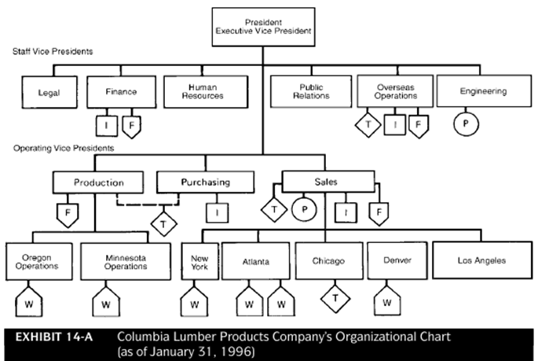

Question 1: Draw a new organization chart for Columbia Lumber Products Company that you feel best overcomes the directors’ criticisms of CLPC’s present (January 31, 1996) organization. Indicate the geographic location of all operations shown on the new chart. Explain why you established the organization chart the way you did.

