The purpose of this simulation project is to provide the individual an opportunity to use the POM software to solve an MRP problem.
POM Software:
For this part of the project, you will need to use the POM software:
- Launch the POM software and from the main menu choose Module-> Materials Resource Planning
- Program the MRP for the problem below and solve it with the use of POM

POM software can be downloaded from:
http://wps.prenhall.com/bp_heizer_opsmgmt_10/

The product structure tree for the finished product A is given below.
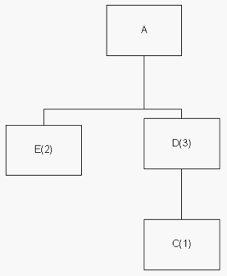

The marketing department is estimating product A's demand to be 60 units for week 4 and 50 units for week 6. There is a scheduled receipt of 75 units for component D at the beginning of week 2. Various other MRP related information for the finished products and the components are provided below.
 |  | A | C | D | E
On hand |  | 12 | 170 | 9 | 5
Lead Time |  | 2 | 2 | 1 | 1
Lot Size |  | LFL | 150+ | multiples of 40 | multiples of 22

3. Provide the MRP tables for all the finished products and the components for the next 6 weeks.

