Use the formula for temperature below to derive a temperature field that looks similar to the figure below using matlab

$$T=a+b\left[\frac{3}{2}.\left(\frac{2}{3}+({sin({φ)})}^{2}\right).\left({\left(sin({φ)}\right)}^{3}\right)\right]$$

Where
$$b=b_{1}×\left(1-\frac{z}{z_{t}}\right)$$

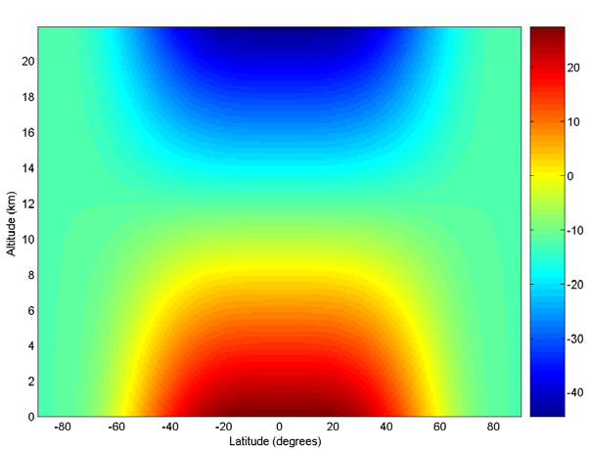

$a=-12 degrees celcious$ φ is latitude in radians (which should vary from the North to the South pole), b₁=40ºC, z is the height above sea level (which should vary from the surface to 22km), z_{T} is the approximate tropopause height (you may assume that this is constant at 12km).

Using the thermal wind shear balance equation derive the corresponding zonal wind field in theNorthern hemisphere.This will require you to calculate the meridional gradient of the temperature to determine the zonal velocities vertical derivative. Using the assumption that the surface wind is zero everywhere you can then derive the zonal wind field using Euler’s method. Remember that thermal wind shear balance is not valid near equator so only derive the zonalwind up to 20ºN.

