Trigonometry/Algebra
1) An open-top box with a square base is to be constructed from 150 square centimeters of material.
What dimensions will produce a box with largest possible volume?

2) Assume h 0. Compute and simplify the difference quotient for f(x) = 1 / x.

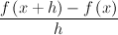

3) Solve the inequality.
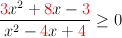

- 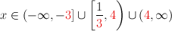
- 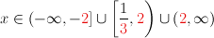
- 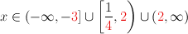
- 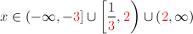
- 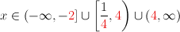

4) Solve the equation without using logarithms.

x=_________ Large x-Value
x=__________ Smaller x-Value

5) Solve the equation.
x=________

