Contents

Introduction 3

Strategies and Criteria of Supplier Selection 3

Supplier Management 4

Supplier Relationship 6

SAP Supplier Relationship Management – the tool 7

Advantages & Disadvantages of SM 8

Negativity of Supplier Management 10

Wal-Mart 11

Conclusion 13

References 14

**Strategies and Criteria of Supplier Selection**

Supplier selection criteria for a particular product or service category should be defined by all related functions and owners. In manufacturing, members of the team typically would include representatives from purchasing, quality, engineering and production. Team members should include personnel with technical, application knowledge of the product or service that need to be purchased. Also it is important to add the members who use the purchased items or service.

**Common Supplier selection criteria**

* Gather previous experience and past performance data
* Relative level of quality system, meeting regulatory requirements, mandated quality system registration such as ISO9001, QS-9000, etc.,
* Meet current and potential capacity requirements, desired delivery schedule
* Financial stability
* Technical support availability, participate as a partner in design and development, long term relationship
* Total cost of dealing and total cost assessment

**Methods of determining**

* Financial report study
* Request for formal quote with specifications and other requirements
* Visit supplier with management and selection team
* Confirmation of quality system by on site assessment or certification of quality system registration
* Discussions with other customers served by the supplier
* Review of databases or industry sources
* Evaluation such as prototyping, lab tests, validation testing of the samples taken from supplier

**Supplier Management**

Supplier management is important to maintain relationship, cost, long term business and so on. On-time deliveries, materials out of spec, packaging and labeling issues and contract breach are a few of the things that must be managed by the buyer and the supplier. These items and many more are the things that can cause a buyer company's costs to go out of control as well as the supplier's costs. Supplier management is a company's way of making sure it is working with the best suppliers. If done well supplier management can save both companies a great deal of money.

* **To achieve success in business in close cooperation with suppliers.**
* **To develop ‘win to win relationships’ with suppliers**
* **To keep active cooperation with suppliers**
* **To have transparent and clear procedure of supplier’s measurement for all stakeholders.**
* **To support purchasers with accurate information.**
* **To strive for long term partnership with suppliers.**

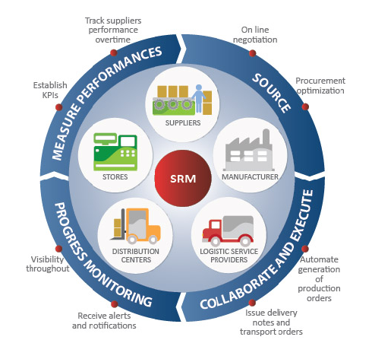

<http://www.ehow.com/about_6694106_define-supplier-management.html>

10th April 11 10am

## Supplier Qualification

Each company has its own way of performing qualifications. Generally, however, the most important things to know about suppliers are if they can make the materials required within specifications and meet the demand of the company's production schedules.

## Supplier Management Software

There is software to aid companies in the supplier management process. The software tracks items and can be customized to meet specialized needs. The capture of data allows the buyer and supplier to use the information to become partners and work together to smooth out this part of the supply chain.

## Processes and Procedures

If a supplier does not have its own internal processes running smoothly, that is a red flag that the supplier will not be able to deliver as required by the buyer. Once a supplier is selected, an audit of the supplier's processes usually takes place and any areas of concern are addressed.

## Contractual Agreement

|  |  |
| --- | --- |
| Once a supplier is deemed able to provide the required raw materials at the specification required and the production rate needed, a supplier/ buyer contract is drawn up with all of the particulars included. Charge-back is one of those items agreed upon by both parties, if the supplier misses due dates or has packaging or labeling discrepancies, it is charged a dollar amount, usually a percentage of the invoice in question. |  |

**SUPPLIER RELATIONSHIPS**

All successful companies build strong relationships with their suppliers. Companies are not isolated entities that simply purchase goods and services from individuals who happen to be able to supply them at that particular time. Companies typically make larger purchases. In reality, successful companies recognize the need to build bridges between their organization and the vendors that they work with by establishing strong

buyer/seller relationships.

Accurate, timely information exchange, Implement a web-based system that allows access on what is needed, when, provide accurate, adequate performance metrics that design specifications for new products are complete, realistic volume estimates for pricing new business.

Realistic Cost Reduction Targets, Work with the supplier to understand the process, the savings opportunities, and then set realistic targets. Also implement a program that shares the savings between both parties in an equitable manner.

Cost avoidance proposals cost reduction If supplier comes up with a new process to produce the product that takes out certain production costs, or a new design that allows for cheaper materials to be used (without affecting performance or quality), that qualifies as a cost reduction.

Provide Lean Experts, This will help both find ways to take waste, and cost, out of the system and demonstrate commitment to success.

Provide Supplier with Free Training Once identify where they need improvement.

Make it clear that the Best Suppliers get the Business, this will reinforce the message that improvement will result in more business, and more profit.

Align purchasing and engineering expectations nothing risks a good relationship more than forcing a supplier to be a referee when there are internal conflicts in the company when it comes to requirements.

Fairly compensate suppliers When don't meet end of the agreement If cancel a program, fail to meet expectations, or change the requirements, don't try to weasel out of your end of the agreement and force the supplier to bear the brunt of sunk costs. Pay for mistake, or award them the new contract with an increased profit margin to allow them to make up their losses.

**SAP SUPPLIER RELATIONSHIP MANAGEMENT – the tool**

The SAP Supplier Relationship Management (SAP SRM) application automates, simplifies, and accelerates procure-to-pay processes for goods and services. With SAP SRM, you can reduce procurement costs, build collaborative supplier relationships, better manage supply bases, and improve your bottom line with innovative offerings and a faster time to market.

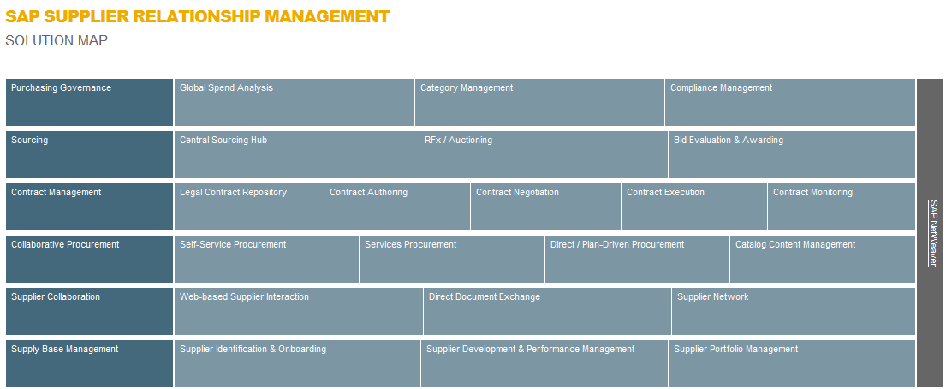

<http://www.sap.com/solutions/business-suite/srm/index.epx> April 12, 2011

**Partnership**

When suppliers are successfully managed, the value to both the supplier and the buyer can be great. Reduction of transportation costs, elimination of production wait time, reduced raw material inventory, more accurate production schedules, lower cost of raw materials and quicker response time to the customer are just a few of the positives that come from successful supplier management. Supplier management is the partnering between a supplier and a buyer working together for positive gains and mutual advantage.

|  |  |  |
| --- | --- | --- |
| **Supplier as a Partner** | | |
| **Aspect** | **Adversary** | **Partner** |
| Number of suppliers | Many | One or a few |
| Length of relationship | May be brief | Long term |
| Low price | Major consideration | Moderately important |
| Reliability | May not be high | High |
| Openness | Low | High |
| Quality | May be unreliable; | At the source; vendor certified |
| Volume of business | May be low | Relatively high |
| Flexibility | Relatively low | Relatively high |
| Location | Widely dispersed | Nearness is important |

**Advantages & Disadvantages of SM**

**Advantages**

Benefits include lower costs, higher quality, better forecasting and less tension between the two entities that result in a win-win relationship

Less tension

Buyer gain a reliable source of the goods they need at a reasonable price and with dependable results. It helps to build up blockade to resist against the increasing competitive market which otherwise can bleed the company’s profit margin with inflating hidden cost.

Lower procurement and relevant processing cost

Buyer don’t have to look for a new vendor each time. A more direct attribute perhaps would be that of heighten accuracy due to the reduction in authorization paperwork required to perform processes is significantly reduce.

Better focus management workforce (Indirect-advantage)

With the paperwork free from the executives and management workforce they can better concentrate on the speciality of “measure, control and facilitate improvement” instead of having their capacity hog by mundane authorization paperwork.

Undisrupted supply

Buyer benefits from better responsiveness in time of need (procurement). Seller receive a steady source of business and revenue

Transparency in handling of product development and production

Can allow constantly monitored inventories and real time information. Presents a chance for co-development of technology to further improve the quality of product and consumer’s satisfaction to product, while at the same time drive the production cost down and other intermediaries hidden cost out.

**Disadvantages**

While not inherit upon perceive, the issue of SRM grows upon the focus SRM encompass, which further complex the issues.

Takes the time develop SRM

Requires a very good relationship with supplier of choice. Requires suppliers collaboration in implementing the system

Trust and transparency or confidentiality

SRM works heavily on trust in order to gain convenience for all firms involved While capable of facilitating extensive product information exchange in between firms involved to allow further pursue of product development and lowering of production margin, this however put the company in a precarious situation when “vital” information confidentiality can pose a threat.

Active participant lost of interest in participating

Perhaps one of the biggest inherit dangers is lost of interest in participating in the collaboration, this can lead to severe consequences that can present it self in various other fore-mention disadvantages

Resource hog to implement SRM from sketch

Time consuming to implement/customised to need based on paperwork and legacy systems

Requires extensive data handling in between firms involved

Data handling in SRM had high risk of encountering data bottlenecking if a automate data handling system is not implement thoroughly through out the supply chain.

Requires significant investment in the initial attempt to adopt SRM data handling software (affect the effectiveness) to avoid data bottlenecking

**Negativity of Supplier Management**

To counter the dangers previously mention, measurements was set place to keep things in check, but this also presented itself in another set of issues

As investments in SRM do not directly attribute monetary returns but rather on controls upon measurement perform on various in firm functions and activities, which have significant impact on the product profit margin.

While it is easy to account for some benefits which are monetary related in natural (example: cost saving in processing cost of procurement)

Or where when the measure is of quantitative nature (example: via the inbound/outbound processes cost reductions which are measured on terms of time and responsiveness required to procure/sell resource and product respectively.)

There are some that involved the measure of quality of product in development(which affects by how consumers perceived function of product), which often presented in complex matrixes through clearly presents the ratios of improvement are often too technical to be understand by an untrained layman.

Of which to measure and control SRM requires an extensively trained cohort of specialized personnel.

**Control and Develop Supplier Relations**

**Supplier Sourcing**

.

**Prequalification Process**

**Continuous Evaluation**

**Supplier Forum**

**Supplier Management**

**Supplier Development**

**Supplier Award**

**Onsite audit at Supplier Facility**

**Supplier block list**

**Supplier Classification**



Wal-Mart used supplier management very effectively. Wal-Mart found sources that supplied good quality products and it negotiated rock-bottom prices with these sources. In addition, Wal-Mart scoured the globe for sources that had cost advantages and developed it supply chain. further, Wal-Mart uses the latest technology to manage its supply chain. We will know how much importance Walmart giving to its suppliers from its CEO’s words.

“At Walmart our Supplier Diversity program is creating an even more diverse foundation for our business and helping us to become truly inclusive. By strengthening our relationships with minority- and women-owned businesses, we are becoming even more relevant to the customers and members that we serve.” **- Mike Duke, president and CEO**

**Sourcing products**

Wal-Mart worked hard with its suppliers and tried to understand the cost structure of manufacturers; it made the purchase process transparent and ensured that its suppliers were making the best efforts to reduce their costs. After driving a hard-bargain, Wal-Mart established long term relationships with these suppliers. Wal-Mart also had the policy of favoring local and regional vendors and suppliers so that transportation costs were minimized.

It set up distribution centers in different geographical locations so that its logistics costs were minimized. The warehouses of Wal-Mart are located in such a manner that shipping costs were minimized. Currently, Wal-Mart’s shipping costs are as low as 3% compared to 5% of its competitors.

Wal-Mart has been sourcing its products also from abroad in terms of low cost. It has a strong source in East Asian countries. Wal-Mart has sourced its good from low cost producing countries like China, Bangladesh, and Vietnam. Wal-Mart has been able to gain competitive advantage because it has been able to get goods produced around the world at different offshore locations at very low prices. Wal-Mart has competitive advantage because it believes in passing the cost advantage it gains from suppliers to consumers. The company has developed skills in obtaining products cheaply through the management of its supply chain. For instance, Wal-Mart buys a large quantity of its goods from China directly and through suppliers. The key to success lies in managing the supply chain efficiently. One of the key reasons why Wal-Mart is able to manage its supply chain to gain competitive advantage is its bargaining power. The supply chain management enables it to get rock bottom prices giving it cost leadership. It high purchasing volumes is an important tool in its supply chain management. Wal-Mart uses the principle of economies of scale in its management of supply chain. The economies help reduce its costs and this gives it competitive advantage. Wal-Mart gains from technical economies since its supply chain related fixed costs are less. Wal-Mart gains in bulk buying, and is able to economize in the use of its administrative fixed costs. Supply chain management helps reduce cost of Wal-Mart and gives it competitive advantage.

**Supplier Management**

Wal-Mart makes extensive use of technology.  Wal-Mart uses information technology to keep up-to-date information about sales as well as good communication with suppliers. It collaborates electronically with thousands of suppliers. On the other side Wal-Mart uses a companywide intranet.*.* The smooth functioning of the supply chain is facilitated by a reliable network infrastructure. The network combined with web-based applications improves the management of supply chain at Wal-Mart. It uses excellent supply management techniques to provide customer satisfaction, low prices, and a superior experience.

Wal-Mart has asked some of its large suppliers to jointly develop supply chain partnerships. The objectives of these partnerships are to reduce costs and increase Wal-Mart’s competitive advantage. For example Wal-Mart has developed a partnership with Procter & Gamble that has incorporated vendor-managed inventory, category management and inter-company innovations. The partnership is developed in such a way that its gives Wal-Mart greater competitive advantage.

**Supplier Management excellency**

Wal-Mart recognize supplier partnerships as diverse as the customers. It created the Supplier Diversity Internal Steering Committee with senior leaders from all of our business units – Operating Divisions’, Marketing, Logistics, International, Information Systems, Legal and Real Estate. The Supplier Diversity Internal Steering Committee has been charged with creating a plan of action for doing business with more minority and women-owned suppliers that enhances both Walmart’s and the suppliers’ business growth.

**Second Tier Suppliers**

The 2nd Tier program encourages our 1st Tier suppliers to report what they spend with minority- and women-owned businesses, as it relates to the business they do with Wal-Mart. In 2009, our 2nd Tier spend was more than $2 billion, bringing our combined spend with minority- and women-owned businesses to nearly $9.2 billion.

**Relationship Management**

Wal-Mart have created business and networking relationships with national supplier development and certification organizations.

* African American Chamber of Commerce
* National Hispanic Chamber of Commerce
* National Minority Supplier Development Council
* Native American Chamber of Commerce
* U.S. Chambers of Commerce
* U.S. Pan Asian American Chamber of Commerce
* Women Business Enterprise National Council

**Conclusion**

Supplier management deals primarily with the oversight and management of materials and services inputs, management of the suppliers who provide those inputs, and support of the process of acquiring those inputs. The performance of supply management departments and supply management professionals is commonly measured in terms of amount of money saved for the organization. However, [managing risk](http://en.wikipedia.org/wiki/Risk_management) is one of the other critical aspects of supply management; especially the risk of non-availability at the required time of quality goods and services critical for an organization's survival and growth.

With the Globalization and the technology availability in today’s world, it is become so easy, convenient to have long term contract with supplier to do business. It is also essential and cost effective for purchasing. It is transparent and easy access to the market. Well managed supplier management will definitely gain competitive advantages to improve and sustain in the business.

**References:**Brunn Stanley,  Wal-Mart world: the world's biggest corporation in the global economy, Routledge, 2006   
Fishman Charles, The Wal-Mart effect: how the world's most powerful company really works-- and how it's transforming the American economy   
Penguin Press, 2006   
Soderquist Don, The Wal-Mart way: the inside story of the success of the world's largest company, Thomas Nelson Inc, 2005

<http://www.ehow.com/about_6694106_define-supplier-management.html#ixzz1J5Dv5koB>

<http://www.ehow.com/about_6694106_define-supplier-management.html> 10th April 11 10am

<http://www.sap.com/solutions/business-suite/srm/index.epx> April 12, 2011

<http://www.ism.ws/files/Pubs/Proceedings/FFGordon.pdf>