1. Which of the following is the correct formula for cell B5 to calculate the earnings per share? |  | 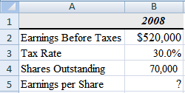
a. =B2-B3*B2/B4
b. =(B2-B3)/B4
c. =B2*(1-B3)/B4
d. =(B2+B3*B2)/B4
e. =B2*(1+B3)/B4
2. What should be the outcome of cell B8? Remember that the basic syntax of the IRR function is: IRR(values,guess)

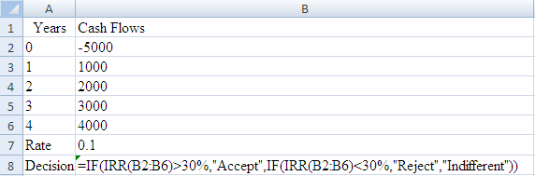
a. “Accept”
b. “Reject”
c. “Indifferent”
d. “IRR=30%”
e. “30%”

3. What is the correct formula to determine the stock price using the earnings model on cell B6? 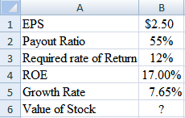
a. =B1*B2/B3+(B1*B2*(B4/B3-1))/(B3-B5)
b. =B1/B3-(B1*(1+B2)*(B4/B3+1))/(B3+B5)
c. =B1/B3+B1*(1-B2*B4/B3-1)/(B3-B5)
d. =B1/B3+(B1*(1-B2)*(B4/B3-1))/(B3-B5)
e. =B1/B3+(B1*(1-B3)*(B2/B3-1))/(B3-B4)

Use the data to the right for the next two problems

4. What is the correct formula for cell B5? | 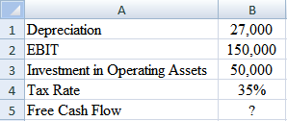
a. =B2*(1-B4)+B3-B1
b. =B2-B4+B1-B3
c. =B2*(1-B4)+B1-B3
d. =B2*(1-B4)-B1+B3
e. =B2/(1-B4)*B1*B3
5. What is the free cash flow?
a. $120,500
b. $117,550
c. $ 82,550
d. $ 74,500

Use the data to the right for the next two problems
6. What should be the formula on cell C4 if you want to determine the expected rate of return of security X using the CAPM model? | 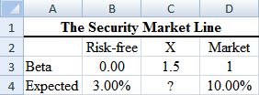
a. =B4+C3*D4-B4
b. =B4+C3*(D4-B4)
c. =B4-C3*(D4+B4)
d. =B4+B3*(D4-B4)
e. =B4+D3*(C4-B4)

7. What is the expected return?
a. 18.0%
b. 10.0%
c. 13.5%
d. 6.5%

8. What is the value of cell B6? | 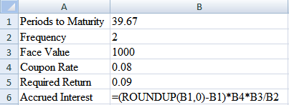
a. 1586.8
b. 26.67
c. 13.2
d. 40
e. 80

Use the following information for the next two problems
 |  | PV
Year | Cash Flow | Cash Flows
1 | $14,000 | $12,726
2 | $14,000 | $11,564
3 | $10,000 | $7,510
4 | $10,000 | $6,830
5 | $8,000 | $4,968

9. What is the NPV of above project if the initial investment was $45,000?
a. $43,598
b. $-1,402
c. $11,000
d. $56,000
10. Calculate the IRR and MIRR of the project, respectively, assuming a cost of capital of 10%.
- -6,57%, 22.56%
- .92%, 16.96%
- -1.24%, 4.32%
- 8.65%, 9.31%

11. What should be the correct formula for cell B5? | 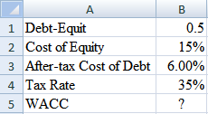
a. =B2/(1-B1)+B3*B4*B1/(1-B1)
b. =B2/(1+B1)+B3*(1-B4)*B1/(1+B1)
c. =B2/(1+B1)+B3*B1/(1+B1)
d. =B2/(1-B4)+B3*B1/(1-B4)
e. =B2/(1-B1)+B3/(1-B1)

2. What is the WACC?
a. 14.62%
b. 42.00%
c. 27.30%
d. 10.50%

Use the data to the right for the next two problems.
13. What should be the correct formula for cell B7 if you want to find the average cost of retained earnings using both the dividend growth model and the CAPM model? | 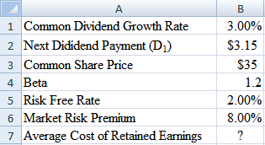
a. =((B2/B3+B1)+(B5+B4*(B6-B5)))/2
b. =((B3/B2+B1)+(B5-B4*B6))/2
c. =((B2/B3+B1)+(B5+B4*B6))/2
d. =(B2/B3+B1+B5+B4*B6)/2
e. =((B3/B2-B1)-(B5-B4*B6))/2

14. What is the value of the average cost of retained earnings?
a. 18.8%
b. 17.8%
c. 11.8%
d. 9.2%

15. What should be the correct formulas for cells B2 and B3? | 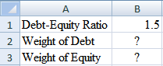
a. =B1/(1-B1) and =1/(1-B1)
b. =B1/(1+B1) and =1/(1+B1)
c. =B1/(1+B1)^2 and =1/(1+B1)^2
d. =B1/(1-B1)^2 and =1/(1-B1)^2
e. =B1/(B1-1) and =1/(B1-1)

16. Using the Net Present Value method of capital budgeting will always lead you to the economically correct decision because_____, however it can be misleading when comparing projects of ____.
- I. NPV represents the change in shareholder wealth that accompanies the acceptance of an investment
II. differing size
- I. NPV considers the time value of money
- differing payback periods
- I. NPV considers the time value of money
- differing size
- I. NPV can be greater than, equal to, or less than zero
II. differing payback periods

Use the data to the right for the next two problems

17. A proposed investment project will generate sales of 3000 units at a price of $20 per unit. The fixed costs are $8,000 and the variable costs per unit are $15. The project requires $20,000 of fixed assets that will be depreciated on a straight-line basis to a zero book value over the project’s 4-year life. If the tax rate is 34%, what should be the formula on cell B8 to calculate the operating after-tax cash flows for year 5? | 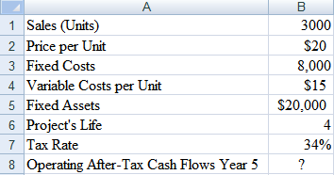
a. =(B1/(B2+B4)+B3)/(1-B7)-(B5*B6/B7)
b. =B1*B2-B4-B3*(1+B7)+B5/B6*B7
c. =(B1*B2-B3)*(1+B7)+B5/B6*B7
d. =(B1*(B2-B4)-B3)*(1-B7)+B5/B6*B7
e. =(B1*(B2-B4)-B3)*B7+B5/B6*B7

8. Find the breakeven point in units and dollars
a. 1600; $32,000
b. 316; $6,320
c. 5600; $112,000
d. 2600; $52,000

Use the data below for the next two problems
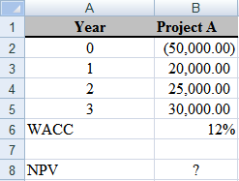
19. Which should be the right formula for cell B8?
a. =NPV($B$6,B2:B5)
b. =NPV($B$6,B3:B5)-B2
c. =NPV($B$6,B3:B5)+B2
d. =NPV($B$6,B2:B5)+B2
- =NPV($B$6,B2:B5)-B2

- What is the NPV?
a. $8,161.07
b. $9,140.40
c. ($41,838.93)
d. $109,140.40

21. In column E, 1 indicates that the project will be selected and zero otherwise. If you want to find the cost weighted average IRR of just those projects that will be selected, what should be the right formula on cell B7 using an array formula? | 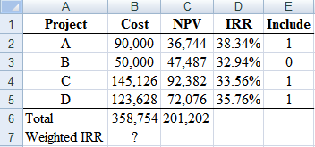
a. =SUM(B2:B5 *$E2:$E5)/B6
b. {=SUM(B2:B5*D2:D5*$E2:$E5)/B6}
c. ={SUM(B2:B5*D2:D5*$E2:$E5)}/B6
d. =SUM(B2:B5*D2:D5*$E2:$E5)/B6
e.{=SUM(B2:B5*$E2:$E5)/B6}

22. As a bank loan officer, you want to reference detailed columnar loan portfolio data with a list of past-due loans. Which of the following is the most effective tool for doings so?
a. Pivot table
b. H Lookup
c. Search function
d. Scatter plot
e. V Lookup
23. Suppose that you are approached with an offer to purchase an investment that will provide cash flows of $1,200 per year for 15 years. The cost of purchasing this investment is $9,800. You have an alternative investment opportunity, of equal risk, that will yield 8% per year. What is the NPV that makes you indifferent between the two options?
a. $10,271.37
b. $436.46
c. $1,197.30
d. $471.37

24. YOUR SOLUTIONS TO THIS PROBLEM SHOULD BE SUBMITTED AS AN EXCEL FILE,

You have decided to invest in an operation that will freeze and ship frozen turkeys.
The figures to be used are as follows

Frozen Turkeys Scenario
Cost of Land $ 170,000
Cost of Buildings & Equipment $ 325,000
MACRS Class 20
Life of Project (Years) 5
Terminal Value of Land $ 275,000
Terminal Value of Buildings & Equipment $ 155,000
First year sales (pounds) 225,000
Price per Pound $3.75
Unit Sales Growth Rate 6.5%
Variable Costs as % of Sales 60%
Fixed Costs 75,000
Tax Rate 35%
WACC 10.5%

1. Prepare a statement of annual cash flows for years 0 through 5. Cash flows in year 0 are your expenses for building and land.
Sales growth is based on the annual growth rate in units.
Assume no changes in fixed or variable costs.
Depreciate the project cost for 5 years, with the cash flow in year 5 to include the terminal cash flow of ending the investment.

2. Calculate the NPV, profitability index, IRR, MIRR, payback and discounted payback of the cash flows in part 1.

3. Prepare a sensitivity table determining from -30% to +30% (i.e., -30,-20,-10, 0, 10, 20, 30) for determining the sensitivity of NPV based on the terminal value of land, value of buildings and equipment, first year of sales, price per point, unit sales growth rate, and variable cost as a percent of sales.

4. Create a sensitivity diagram (all variables from 3 on one chart)

5. Using scenario manager find best case, worst case, base case of NPV based on sales in pounds, price per pound, and variable cost percent.

