E11 – 5 Depreciation methods
For each of the following depreciable assets, determine the missing amount (?). Abbreviations for depreciation methods are SL for straight line, SYD for sum-of-the-years' digits, and DDB for double-declining balance.
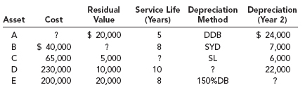

E 11-10 |  | Double-declining-balance method; switch to straight line
On January 2, 2011, the Jackson Company purchased equipment to be used in its manufacturing process. The equipment has an estimated life of eight years and an estimated residual value of $30,625. The expenditures made to acquire the asset were as follows:
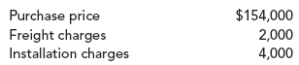
Jackson's policy is to use the double-declining-balance (DDB) method of depreciation in the early years of the equipment's life and then switch to straight line halfway through the equipment's life.
Required:
1. |  | Calculate depreciation for each year of the asset's eight-year life.
2. |  | Discuss the accounting treatment of the depreciation on the equipment.

