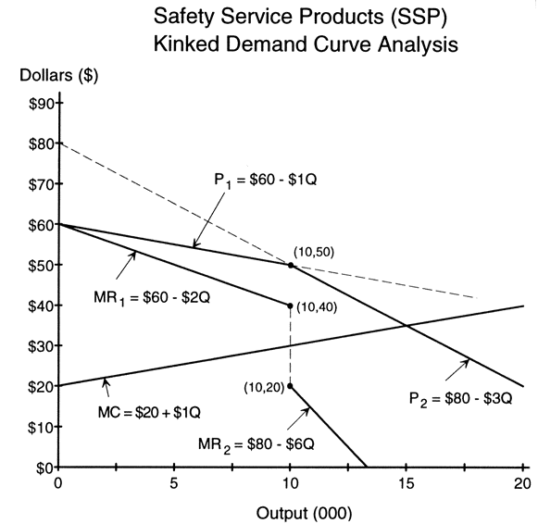

2. Assume the above graph depicts a firm that tries to maximize profits or minimize losses. Also assume this firm has a Total Cost Equation of 150 + 20Q + .5Q², and a demand curve that can be described by the equation P = 60 -1Q Answer the following questions on the above firm, and show your work to receive full credit.
- How much are the firm’s Fixed Costs?
- Assuming this firm’s operates at its profit-maximizing output, what is that quantity of output?
- At its profit-maximizing output, what is the firm’s profit or loss?
- The firm has a marginal cost equation that is shown above as MC=$20+$1Q. Suppose something happens to cause that equation to change to MC=$22+$1Q. How does this change in the firm’s cost structure impact its profit-maximizing output and price? What practical implications for the firm’s customers does your answer have?

