A Company surveys 32 randomly selected employees and ask the number spent working at home after hours during a week. The results as shown below:
10 | 5 | 0 | 8
0 | 3 | 4 | 4
2 | 3 | 8 | 1
4 | 1 | 7 | 5
7 | 6 | 2 | 1
0 | 5 | 7 | 5
10 | 5 | 3 | 6
6 | 2 | 2 | 3

Using Excel, construct a 90% confidence interval for the mean hours worked.
90% confidence interval: __________ +/- ________
Round your final answer to two decimal places.

The weights (in ounces) of 12 randomly sampled cakes as shown in the table below.
17 | 10 | 15 | 14
16 | 12 | 16 | 13
20 | 11 | 17 | 18
Using Excel, constructed a 98% confidence interval using a t-distribution for the mean weight.
98% confidence interval: _________+/- __________
Round your final answer to two decimal places.

In a survey of 942 musicians, 715 said they began playing an instrument while in elementary school.
Using Excel, construct a 90% confidence interval for the proportion of the musicians who began playing an instrument while in elementary school.
90% confidence interval: _________ +/- __________
Round your final answer to two decimal places.

A restaurant wants to estimate the average number of customer who ask for refills on coffee. They want to be within 5 of the true mean when using a confidence interval of 99%. The standard deviation is estimated at 30.
How many customers must they sample?
Customers: ______
Round your answer up to a whole number, if needed.

A community wants to estimate the proportion of residents who are pet owners. They want to be within 8% of the true proportion when using a confidence interval of 90%.
How many residents must be sampled if no preliminary estimate is available?
Remember when calculation a sample size, we need to round up to the next whole number (not to the closest whole number) if needed.
Residents: _______
Round your answer up to a whole number, if needed.

t- Distribution chart
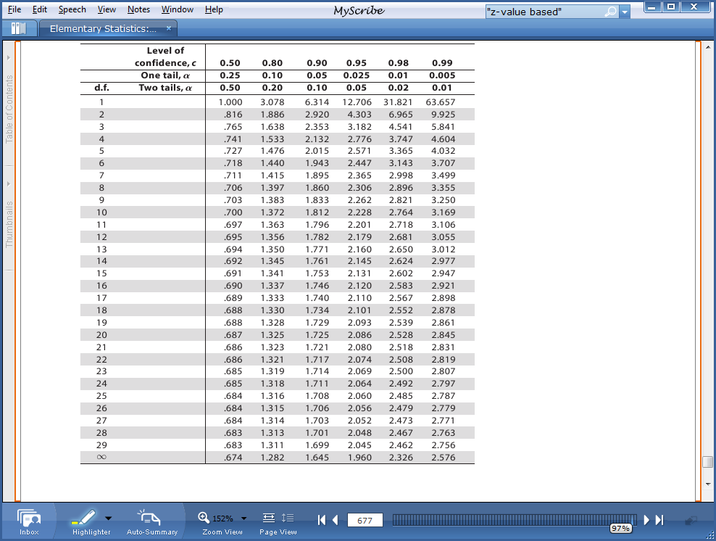

Chi-square Distribution
