1. The weight in pounds of ten randomly-selected football players are:
245, 304, 310, 251, 195
185, 230, 264, 315, 196
Find the median of these weights.
2. The price in dollars of a gallon of gasoline at the end of each month is recorded for one year. The results are:
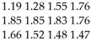
Find the midrange of these prices.
3. To get a C in history, Nandan must average 74 on four tests. Scores on the first three tests were 69, 75, and 60. What is the lowest score that Nandan can get on the last test and still receive a C?

4. The table below gives the total spectator attendance for various U.S. sports in 1997.
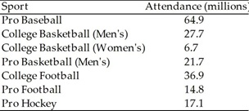
Determine to the nearest tenth the median of these attendance numbers.
5. State College's baseball team had the following scores in their last 8 games: 14, 5, 6, 0, 6, 9, 6, and 15. Determine to the nearest tenth the mean of these scores.
Expectations:
Compute measures of central tendency and a dispersion measure and be able to make appropriate decision based on these computations.

