- Write a 500 – 1050 word paper based upon the tube drawing process described below.
- Identify and discuss the main bottleneck in this process.
- Apply Goldratt’s theory of constraints to identify and overcome process bottlenecks.

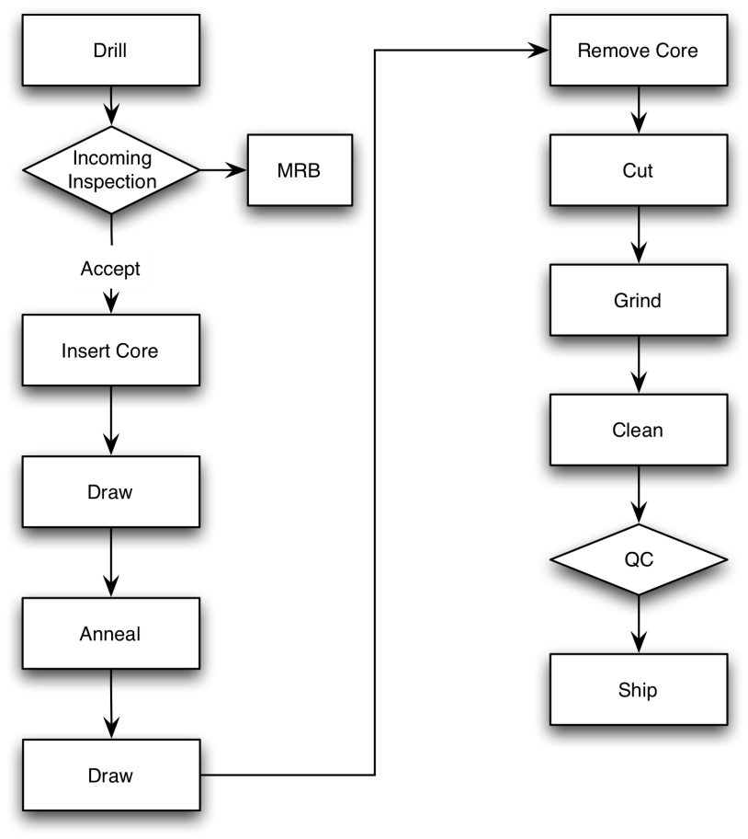

The flowchart above depicts one process for manufacturing metal tubing. Production capacities are listed in the following table.

Operation | Machines | Capacity  Ft / Day / Machine | Operators | Comments
Drill | 1 | 3000 | 1 | Supplier process
Inspection |  | 3000 | 4
Insert Core | 1 | 300 | 1
Draw | 2 | 150 | 1
Anneal | 2 | 150 | 2
Draw | 2 | 150 | 1
Remove Core | 2 | 50 | 2
Cut | 1 | 50 | 1
Grind | 1 | 100 | 1
Clean | 2 | 150 | 2
QC | 1 | 2000 | 4
Ship |  | 2000 | 2

Process Description

Drill – Done outside by a contractor in New York. Our factory is located in California so shipping time is included in the capacity calculation.

Inspection – QC checks to see that we have received the right thing. If the tube is the wrong size, we put it back into stock (MRB) to see if there is something we can use if for later.

Insert Core – Insert a soft core in the tube so that it will maintain shape through the process.

Draw – Squeezes the tube through a die to reduce the diameter

Anneal – Heat treat the tube at high temperature to relieve stress

Draw – Reduces the tube diameter again

Remove Core – There are two machines available for this operation. If the core was not inserted properly, there can be yield problems or the time to process can be unusually long. With one machine it is only possible to remove core from 50 feet of tube each day. The machine to remove the core was designed by our engineers and the cost of a new machine is $20,000

Cut – There is only one saw to cut the tube. It can only cut 50 feet a day. A new machine would cost $150,000 but it would be able to cut 200 feet a day.

Clean – Cleaning is done manually. During cleaning operators also inspect the tubes for straightness and scratches. Adding cleaning stations would be relatively inexpensive.

Inspect – QC inspects the tubes for diameter, length, surface scratches and straightness. Ten percent of the lots are rejected and will either be sent back for rework or scrap.

Ship – Shipping has sufficient capacity but they need to wait for a minimum lot of 100 feet before shipping. At the end of the month wait time can slow things down.

