5-36 Special-Order Decision
Belltown Athletic Supply (BAS) makes game jerseys for athletic teams. The F. C. Kitsap soccer club has offered to buy 100 jerseys for the teams in its league for $15 per jersey. The team price for such jerseys normally is $18, an 80% markup over BAS’s purchase price of $10 per jersey. BAS adds a name and number to each jersey at a variable cost of $2 per jersey. The annual fixed cost of equipment used in the printing process is $6,000, and other fixed costs allocated to jerseys are $2,000. BAS makes about 2,000 jerseys per year, so the fixed cost is $4 per jersey. The equipment is used only for printing jerseys and stands idle 75% of the usable time.
The manager of BAS turned down the offer, saying, “If we sell at $15 and our cost is $16, we lose money on each jersey we sell. We would like to help your league, but we can’t afford to lose money on the sale.”

1. Compute the amount by which the operating income of BAS would change if it accepted F. C.
Kitsap’s offer.
2. Suppose you were the manager of BAS. Would you accept the offer? In addition to considering the quantitative impact computed in requirement 1, list two qualitative considerations that would influence your decision—one qualitative factor supporting acceptance of the offer and one supporting rejection.

5-37 Unit Costs and Total Costs
You are a CPA who belongs to a downtown business club. Annual dues are $150. You use the club solely for lunches, which cost $9 each. You have not used the club much in recent years, and you are wondering whether to continue your membership.

1. You are confronted with a variable-cost plus a fixed-cost behavior pattern. Plot each on a graph, where the vertical axis is total cost and the horizontal axis is annual volume in number of lunches.
Also plot a third graph that combines the previous two graphs.
2. What is the cost per lunch if you pay for your own lunch once a year? Twelve times a year? Two hundred times a year?
3. Suppose the average price of lunches elsewhere is $10. (a) How many lunches must you have at the luncheon club so that the total costs of the lunches would be the same, regardless of where you ate for that number of lunches? (b) Suppose you ate 200 lunches a year at the club. How much would you save in relation to the total costs of eating elsewhere?

6-49 Hotel Pricing and Use of Capacity
A growing corporation in a large city has offered a 200-room Holiday Inn a 1-year contract to rent 40 rooms at reduced rates of $50 per room instead of the regular rate of $86 per room. The corporation will sign the contract for 365-day occupancy because its visiting manufacturing and marketing personnel are virtually certain to use all the space each night.
Each room occupied has a variable cost of $12 per night (for cleaning, laundry, lost linens, and extra electricity).
The hotel manager expects an 85% occupancy rate for the year so she is reluctant to sign the contract.
If the contract is signed, the occupancy rate on the remaining 160 rooms will be 95%.

1. Compute the total contribution margin for the year with and without the contract. Is the contract profitable to Holiday Inn?
2. Compute the lowest room rate that the hotel should accept on the contract so that the total contribution margin would be the same with or without the contract.

6-53 Use of Available Facilities
The Oahu Audio Company manufactures electronic subcomponents that can be sold as is or can be processed further into “plug-in” assemblies for a variety of intricate electronic equipment. The entire output of subcomponents can be sold at a market price of $2.20 per unit. The plug-in assemblies have been generating a sales price of $5.70 for 3 years, but the price has recently fallen to $5.30 on assorted orders.
Janet Oh, the vice president of marketing, has analyzed the markets and the costs. She thinks that production of plug-in assemblies should be dropped whenever the price falls below $4.70 per unit.
However, at the current price of $5.30, the total available capacity should currently be devoted to producing plug-in assemblies. She has cited the data in Exhibit 6-7.
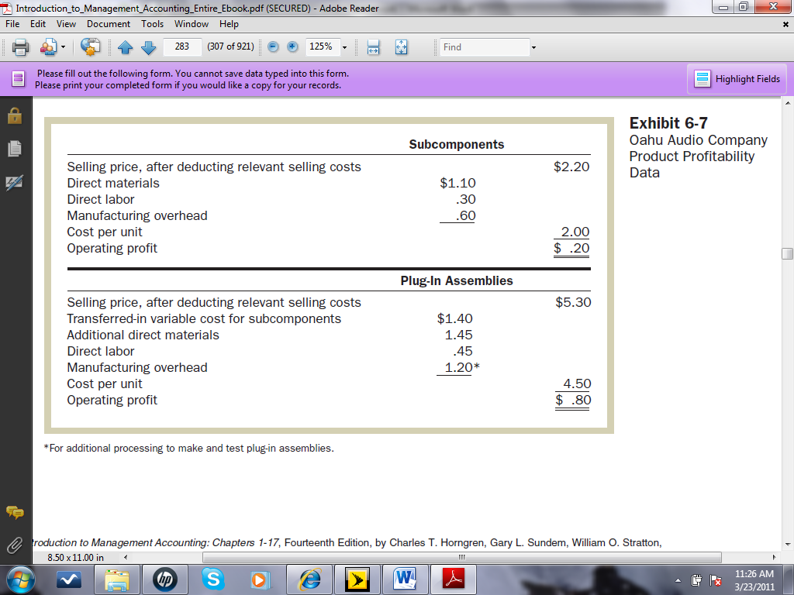
Direct-materials and direct-labor costs are variable. The total overhead is fixed; it is allocated to units produced by predicting the total overhead for the coming year and dividing this total by the total hours of capacity available.
The total hours of capacity available are 600,000. It takes 1 hour to make 60 subcomponents and
2 hours of additional processing and testing to make 60 plug-in assemblies.

1. If the price of plug-in assemblies for the coming year is to be $5.30, should sales of subcomponents be dropped and all facilities devoted to the production of plug-in assemblies? Show your computations.
2. Prepare a report for the vice president of marketing to show the lowest possible price for plug-in assemblies that would be acceptable.
3. Suppose 40% of the manufacturing overhead is variable with respect to processing and testing time. Repeat numbers 1 and 2. Do your answers change? If so, how?

