Required
Chapter 1 Six Sigma Methodology
Chapter 11 Normal Data and Z-Value in
Brussee, Warren (2004) Statistics for Six Sigma Made Easy, Publisher: McGraw-Hill
ISBN: 9780071433853
Here is a table in the book that you will find useful in the homework assignment.

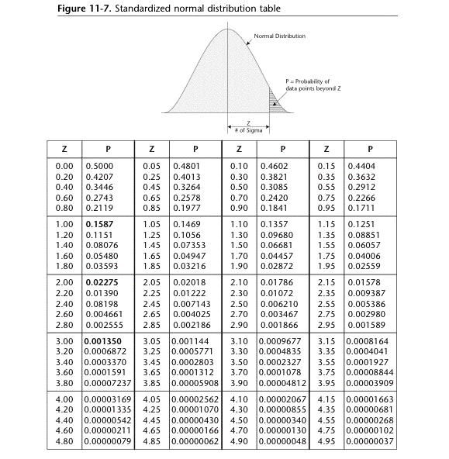

Optional
Available in our e-brary. When you log into your Coursenet account, you will be able to access “eBrary” from the menu of options under “Resources” on the left-hand side of the screen. From here, you can directly enter into E-brary. Please search for the title of the book or the name of the author(s), then you will see the book. Click on the book to browse.
Przekop, Penelope (2005) Six Sigma for Business Excellence Publisher: McGraw-Hill ISBN: 9780071448093
Sleeper, Andrew (2005) Design for Six Sigma Statistics Publisher: McGraw-Hill Professional Publishing ISBN: 9780071451628
Keller, Paul and Pyzdek, Thomas (2004) Six Sigma Demystified : A Self-Teaching Guide Publisher: McGraw-Hill Companies ISBN: 9780071445443 9
Pyzdek, Thomas (2003) Six Sigma Handbook
Publisher: McGraw-Hill Trade
ISBN: 9780071410151

