1. PERT & CPM

Widgetco is about to introduce a new product. One unit of this product is produced by assembling subassembly 1 and subassembly 2. Before production begins on either subassembly, raw materials must be purchased and workers must be trained. Before the subassemblies can be assembled into the final product, the finished subassembly 2 must be inspected. A list of activities, their predecessors, and their durations is given in the following Table.

|  |  |  |
| --- | --- | --- |
| Activity | Predecessors | Duration(days) |
| A – Train workers | --------- | 6 |
| B – Purchase raw materials | --------- | 9 |
| C – Make subassembly 1 | A,B | 8 |
| D – Make subassembly 2 | A,B | 7 |
| E – Inspect subassembly 2 | D | 10 |
| F – Assemble Subassemblies | C,E | 12 |

Problem:

1. Draw a project diagram (network) for this project?
2. What is the total project time?
3. What is the critical path?
   1. Network Diagram
4. Forward Pass

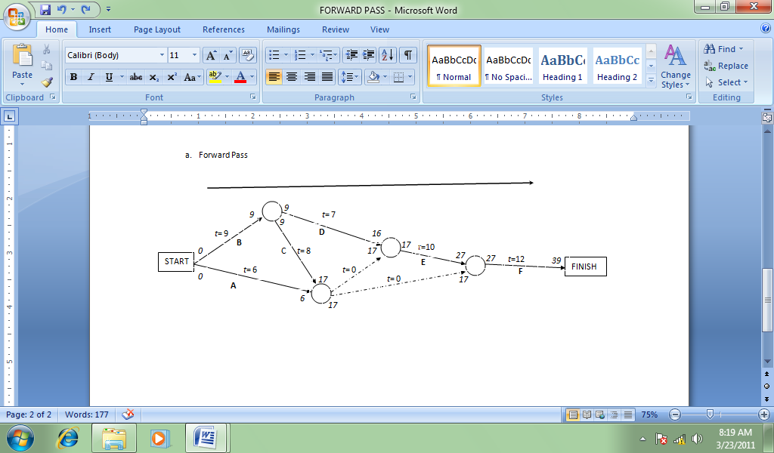

Figure 1. Forward Pass

I call this network as forward pass because the direction and computation of time is from left to right. There were two dummy lines created (the dashed lines) because in PERT/CPM no nodes should be left hanging.

In computing the time, steps have to be followed:

* + 1. Starting time is 0.
    2. Computation is from left to right, hence the direction of the arrows. Add the time.
    3. At the nodes, the time that yields the highest figure should be used.

In computing for the ES (Earliest Start Time) and EF (Earliest Finish Time), see the figure below:

*Earliest Finish Time (EF)*

*for Activity B.*

*Earliest Finish Time (EF)*

*for Activity D.*

9

*9*

*0*

*0*

**D**

C

**B**

**A**

*t*= 7

*t*= 6

*t*= 9

START

*17*

*16*

*Earliest Start Time (ES)*

*for Activity D.*

*Earliest Start Time (ES)*

*for Activity B.*

*6*

*t*= 0

*17*

*17*

*Remember to use the highest time at the node. In this case 17 is used because it is higher than 6.*

*Remember to use the highest time at the node. In this case 17 is used because it is higher than 16.*

You can now construct the partial table for EF and ES.

Table 1. Values for ES and EF

|  |  |  |  |  |
| --- | --- | --- | --- | --- |
| **Activity** | **ES** |  | **EF** |  |
| A | 0 |  | 6 |  |
| B | 0 |  | 9 |  |
| C | 9 |  | 17 |  |
| D | 9 |  | 16 |  |
| Dummy |  |  |  |  |
| E | 17 |  | 27 |  |
| Dummy |  |  |  |  |
| F | 27 |  | 39 |  |

1. Backward Pass

START

*t*=12

*This number (39) is used since this is the total obtained in the forward pass.*

**F**

**E**

**D**

C

**B**

**A**

*t*= 0

*t*= 0

*t*=10

*t*= 8

*t*= 6

*t*= 9

FINISHH

**E**

**D**

C

**B**

**A**

*t*= 0

*t*= 0

*t*=12

*t*=10

*t*= 8

*t*= 7

*t*= 6

*t*= 9

FINISHH

START

**F**

*39*

*t*= 7

*9*

*9*

*11*

*0*

*10*

*17*

*17*

*27*

*39*

*27*

*17*

*17*

*27*

Figure 2. Backward Pass

I call this network as backward pass because the direction and computation of time is from right to left. There were two dummy lines created (the dashed lines) because in PERT/CPM no nodes should be left hanging.

In computing the time, steps have to be followed:

* + 1. Starting time is 0.
    2. Computation is from right to left, hence the direction of the arrows. Subtract the time.
    3. At the nodes, the time that yields the smallest figure should be used.

In computing for the LS (Latest Start Time) and LF (Latest Finish Time), see the figure below:

*Latest Start Time (LS)*

*for Activity E.*

*Latest Finish Time (LF)*

*for Activity E.*

*Latest Start Time (LS)*

*for Activity F.*

*Latest Finish Time (LF)*

*for Activity F.*

*17*

*27*

*t*=12

*27*

*39*

**F**

**E**

*t*=10

FINISHH

You can now construct the table for LS and LF.

Table 2. Values for ES, LS, EF, LF, Slack Time and Critical Path

|  |  |  |  |  |  |  |
| --- | --- | --- | --- | --- | --- | --- |
| **Activity** | **ES** | **LS** | **EF** | **LF** | **Slack time** | **Critical Path** |
| A | 0 | 11 | 6 | 17 | 11 | No |
| B | 0 | 0 | 9 | 9 | 0 | Yes |
| C | 9 | 9 | 17 | 17 | 0 | Yes |
| D | 9 | 10 | 16 | 17 | 1 | No |
| Dummy |  |  |  |  |  |  |
| E | 17 | 17 | 27 | 27 | 0 | Yes |
| Dummy |  |  |  |  |  |  |
| F | 27 | 27 | 39 | 39 | 0 | Yes |

Compute the Slack time using the formula:

Slack time = LF – EF or LS – ES

The Critical Path is when the Slack Time is zero. This means that activities with 0 slack time should never be delayed. A delay of any activities within the critical path means a delay in the entire project.

Critical Path Activities (B-C-E-F) is shown in the figure below:

**F**

**E**

**D**

C

**B**

**A**

*t*= 0

*t*= 0

*t*=12

*t*=10

*t*= 8

*t*= 7

*t*= 6

*t*= 9

FINISHH

START

Figure 3. Critical Path

Problem:

* 1. Draw a project diagram (network) for this project? (see the figures above)
  2. What is the total project time? Answer: 39 days
  3. What is the critical path? Answer: Activities B-C-E-F