5. You are in charge of a major new product development project for your company. Instead of presenting the details of your analysis, you aggregate all three elements of this product into a simple PERT network to present to senior management as shown below. You would like to introduce simulation as a project management tool for your company and you feel that this product has enough visibility to persuade senior management of its utility. Using Crystal Ball, develop a plot of project duration as a function of probability of completion (please cut and paste the spreadsheet along with the cumulative frequency view).

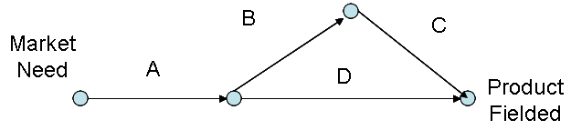

Where

A = Requirements gathering (uniformly distributed varying between 3 and 5 week)
B = Develop prototype and test market (normally distributed with a mean of 5 weeks and a standard deviation of 3)
C = Manufacture and distribute new product (uniformly distributed varying between 5 and 8 week)
D = Advertising, trade shows, market to distributors, etc. (fixed at 11 weeks)

