Manufacturing Cost Classification
A company makes DVD players and incurs a variety of different costs. Place a check in the appropriate column if the cost is a product cost or a period cost. Further, classify each product cost as direct materials, direct labor, or manufacturing overhead.
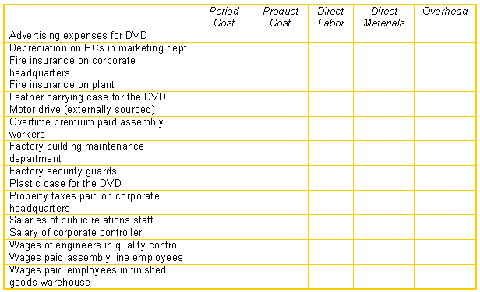
Used by permission of McGraw-Hill.

Medical Instruments
Medical Instruments produces a variety of electronic medical devices. Medical Instruments uses a standard cost system and computes prices variances at the time of purchase. One product, a thermometer, measures patient temperatures orally. It requires a silver lead with a standard length of 5 inches per thermometer. To make the leads, hollow silver tubing is purchased at a standard price of $4 per inch, cut into the required length, and then assembled into the thermometer.
There was no silver tubing in inventory when a batch of 200 thermometers was scheduled for production. Twelve hundred inches of silver tubing were purchased for $4,680 by the purchasing department for this 200-unit batch of thermometers, and 1,100 inches were used in production.
Required:
Compute the materials variances for silver tubing and comment on their meaning.
Used by permission of McGraw-Hill.

Mickles Ltd.
Mickles Ltd. uses a standard cost system. In June, Mickles’ direct labor efficiency variance was $1,470 U and its direct labor rate variance was $825 F. Mickles manufactured 460 batches of product in June. Actual direct labor hours in June were 980 hours. Each batch calls for two standard direct labor hours per batch.
Required:
Calculate the standard direct labor wage rate used by Mickles in computing its direct labor variances in June.
Used by permission of McGraw-Hill.

Alexander Products
Alexander Products manufactures dental equipment and uses a standard cost system. A new product (HV65) that is being introduced requires a particular type of stainless steel. Alexander purchased a quantity of this stainless steel (in meters). The following data summarize the operations regarding the purchase and use of this new stainless steel.
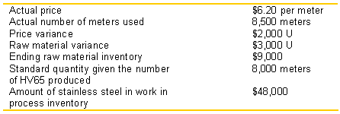
Required:
Calculate the number of meters of stainless steel purchased and the standard price per meter of the stainless steel Alexander used in its standard cost system.
Used by permission of McGraw-Hill.

Oaks Auto Supply
Oaks Auto Supply just acquired a patent on an antifreeze recycler that flushes used antifreeze from a car, filters it, removes dissolved chemicals, and the returns it to the automobile without having to dispose of the old antifreeze or use new antifreeze. It is a cheaper and environmentally safer process than replacing the old antifreeze. The recycler will be sold to garages and auto service shops. The patent cost Oaks $2.2 million. The firm will have to invest another $12.6 million in plant, equipment, and working capital. Oaks has a pretax cost of capital of 20%. In order to achieve this level of sales, the firm forecasts that the sales price cannot exceed $2,500 per recycler. Variable selling commissions will be $500 per unit. Purchased parts are projected to cost $750 per unit.
Required:
Calculate the target conversion cost (labor and overhead) per recycler if Oaks is to achieve its sales projections and return on investment objectives.
Used by permission of McGraw-Hill.

AN7-X1
A new pharmaceutical drug calls for 4.5 ounces of compound AN7-X1 per batch of 250 tablets. AN7-X1 has a standard price of $2 per ounce. An initial inventory of 8,000 ounces of AN7-X1 is purchased for $17,200. The firm produces 1,000 batches of the new drug and uses 4,600 ounces of AN7-X1. All variances are calculated as soon as possible.
Required:
Calculate the price and quantity variances for AN7-X1.
Used by permission of McGraw-Hill.

