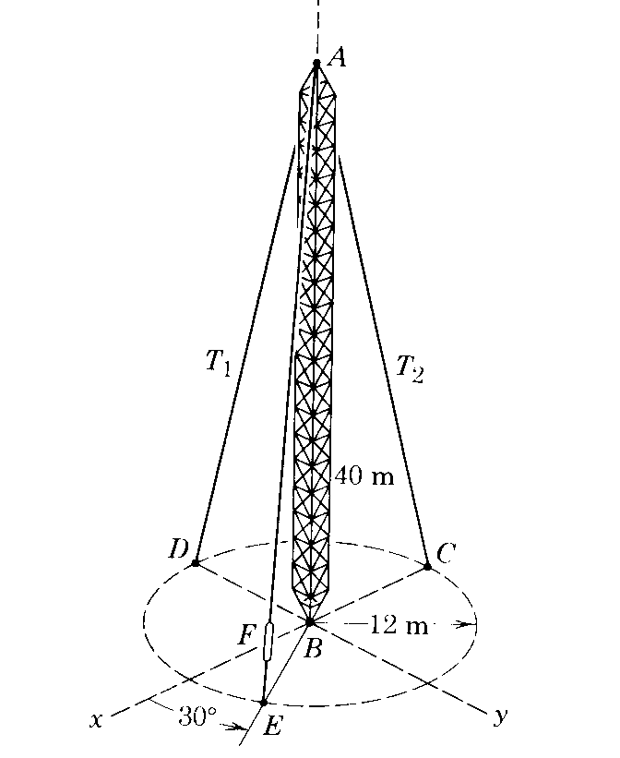
A radio tower has a mass of 1200 kg and is supported in the vertical position by three cables from its top at A. A tensioning device at F records a tension of 4∙8 kN in cable AE. Determine the tensions in each of the other two cables.

