FIGURE 4 shows two inductances connected in parallel across an a.c.
supply.
(a) Apply Kirchhoff’s voltage law to each loop of circuit.

(b) Hence or otherwise obtain the current ratio I1/I2 in terms of the circuit

inductances.
(c) See if you can show that L1 and L2 can be replaced by the equivalent
L1 L2 – M 2
inductor of FIGURE 4 where Leq = −−−−−−−−−−−−−
L1 + L2 – 2 M
(d) A 1 nF capacitor is placed across the two inductors (FIGURE 4 (c)).
If L1 = L2 = L and k = 0.5, determine the required value of L if the
minimum current I flows from the supply when it is at a frequency of
1 MHz.

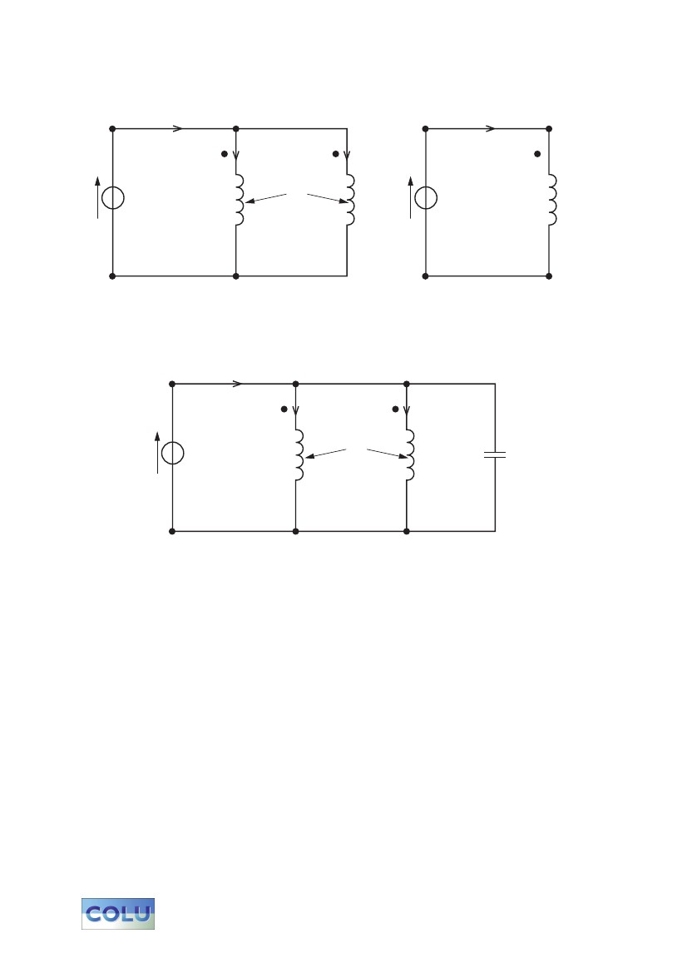
6
I
I1
V
L1
M
I2
L2
V
Leq
I
(a)
I
I1
V
L1
M
I2
L2
(b)
(c)
FIG. 4

