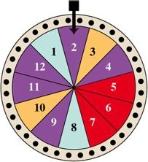
Sec 12.7
If the wheel is spun and each section is equally likely to stop under the pointer, determine the probability that the pointer lands on
20. a number greater than 6, given that the color is red.

28. Mendel Revisited A pea plant must have exactly one of each of the following pairs of traits: short (s) or tall (t); round (r) or wrinkled (w) seeds; yellow (y) or green (g) peas; and white (wh) or purple (p) flowers (for example, short, wrinkled, green pea with white flowers).
a) How many different classifications of pea plants are possible?
b) Use a tree diagram to determine all the classifications possible.
c) If each characteristic is equally likely, find the probability that the pea plant will have round peas.
d) Determine the probability that the pea plant will be short, have wrinkled seeds, have yellow seeds, and have purple flowers.

8. essay; show all work. Last fall, a gardener planted 95 iris bulbs. She found that only 80 of the bulbs bloomed in the spring.

Find the empirical probability that an iris bulb of this type will bloom. Give answer as a fraction in lowest terms.
How many of the bulbs should she plant next fall if she would like at least 91 to bloom?

