1.
You are warming up with the dice in the lobby of a casino before making your move to the casino floor. Suppose you have two regular 6-sided dice, with sides numbered from 1 to 6 on each die. What is the probability of rolling them both at once, and getting a sum of TEN?
Probability =
Round your final answer to two decimal places.
2.
Suppose you and your two friends are part of a group of 15 potential jurors at Rolling Hills District Court. If three people from this group are to be chosen at random for the last remaining seats on the jury, what is the probability that you and your two friends are the last three people chosen?
Probability =
Round your answer to four decimal places.
3.
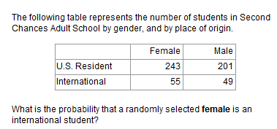
Probability =
Round your final answer to two decimal places.
4.
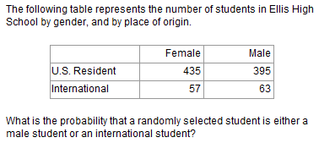
Probability =
Round your final answer to two decimal places.
5.
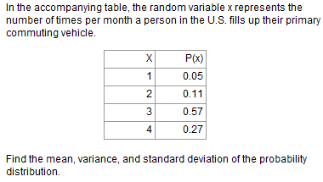
Mean =
Variance =
Standard deviation =
Round all answers to two decimal places.

