ONLY NEED AWNSERS NO WORK NEEDS TO BE SHOWN
1.
Suppose that you have two regular 6-sided dice, with sides numbered from 1 to 6 on each die. What is the probability of rolling them both at once, and getting a sum of seven? Express your answer as a decimal and round your final answer to two decimal places.
Probability =
2.
Suppose that you and your friend are part of a group of 14 potential jurors. If two people from this group are to be chosen at random for the last remaining seats on the jury, what is the probability that you and your friend are the two people chosen? Express your answer as a decimal and round your final answer to two decimal places.
Probability =
3.
Suppose that you and your two friends Dora and Josh are at a small birthday party that has 10 people attending including the three of you. At the end of the party there’s a drawing with a first, second, and third prize. What is the probability that you win the first prize, Dora wins the second, and Josh wins the third? Express your answer as a decimal and round your final answer to four decimal places.
Probability =
4.
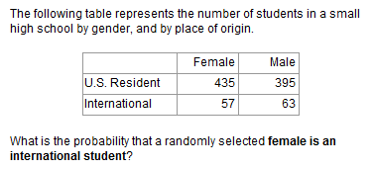
Express your answer as a decimal. Round your final answer to two decimal places.
Probability =

5.
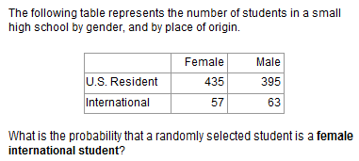
Express your answer as a decimal. Round your final answer to two decimal places.
Probability =
6.
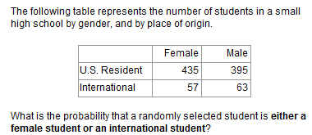
Express your answer as a decimal. Round your final answer to two decimal places.
Probability =
7.
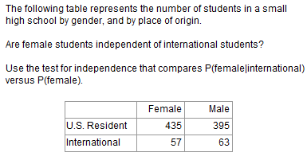

P( female|international ) =
P( female ) =
Express your answers as decimals. Round your final answers to three decimal places.
8.
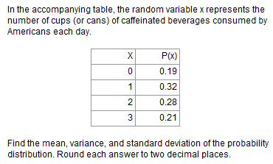
Mean=
variance =
Standard deviation=
Round your answers to two decimal places.

