1) The production engineers at Impact Industries have derived the expansion path shown in the following figure. The price of labor is $100 per unit.

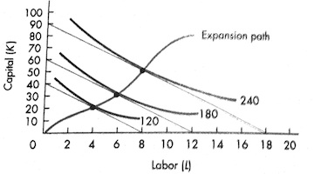

a) What price does Impact Industries pay for capital?
b) If the manager at Impact decides to produce 180 units of output, how much labor and capital should be used in order to minimize total cost?
c) What is the total cost of producing 120, 180, and 240 units of output in the long run?
d) Impact Industries orginally built the plant (i.e., purchased the amount of capital ) designed to produce 180 units optimally. In the short run with capital fixed, if the manager decides to expand production to 240 units, what is the amount of labor and capital that will be used? (Hint: How must the firm expand output in the short run when capital is fixed?)
e) Given your answer to part d, calculate average variable, average fixed, and average total cost in the short run.

